Concept 4: Community Ecology – Analyzing the interactions and relationships within and between species and the effects of environmental factors on species diversity and composition.

Community Ecology (Ch 54)
  - The difference between a fundamental niche and a realized niche
  - The role of competitive exclusion in interspecific competition
  - The symbiotic relationships of parasitism, mutualism, and commensalism
  - The impact of keystone species on community structure
  - The difference between primary and secondary succession
Community Structure
How do the following principles relate to each other? What are some examples?
Trophic Structure
- Food Chain
- Food Web

Species Diversity
- Dominant Species
- Invasive Species
- Keystone Species
- Foundation Species

Trophic Structure
The feeding relationships between organisms in a community
Key factor in community dynamics!
Illustrated by:
- food chains - link trophic levels from producers to top carnivores
- food webs - branching food chain with complex trophic interactions
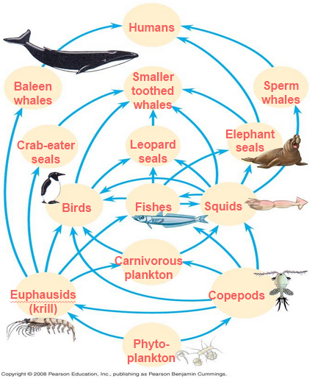
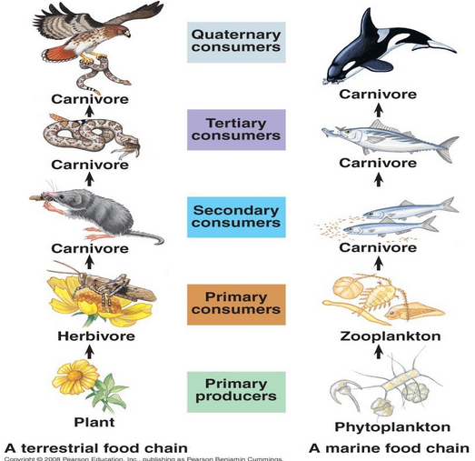

Food webs can be simplified by isolating a portion of the community that interacts very little with the rest of the community
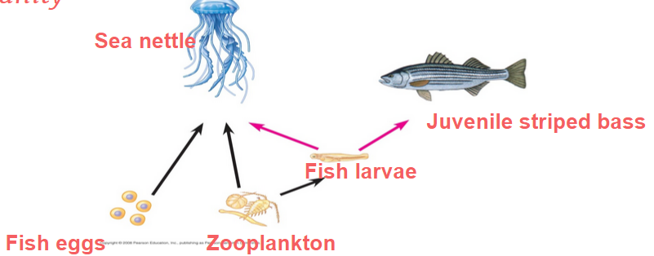

How is the food chain limited?

- Each food chain in a food web is usually only a few links long
- Two hypotheses attempt to explain food chain length:
- The energetic hypothesis suggests that length is limited by inefficient energy transfer
- The dynamic stability hypothesis proposes that long food chains are less stable than short ones

Try This
Which of the following organisms and trophic levels is mismatched?
A) algae – producer
B) phytoplankton – primary consumer
C) fungi – decomposer
D) carnivorous fish larvae – secondary consumer
E) eagle – tertiary or quaternary consumer

Species Impact
Certain species have a very large impact on community structure

Dominant species are those that are most abundant or have the highest biomass (total mass of all individuals in a population).
Example: sugar maple
Exert powerful control over the occurrence and distribution of other species
Two hypotheses:
1) Most competitive in exploiting resources
2) Most successful at avoiding predators

Invasive species, typically introduced to a new environment by humans, often lack predators or disease.
Ex) Atlantic salmon in pacific waters

Keystone species exert strong control on a community by their ecological roles, or niches
In contrast to dominant species, they are not necessarily abundant in a community
Examples:

Foundation species (ecosystem “engineers”) cause physical changes in the environment that affect community structure
Example: beaver dams can transform landscapes on a very large scale
Some foundation species act as facilitators that have positive effects on survival and reproduction of some other species in the community
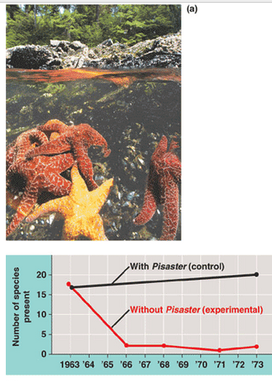

Keystone Species
Field studies of sea stars exhibit their role as a keystone species in intertidal communities
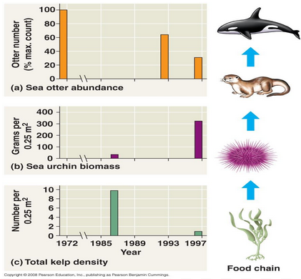
Observation of sea otter populations and their
predation shows how otters affect ocean
communities

Bees as keystone species

Species Diversity
The variety of organisms that make up the community
Two components:
1) Species richness is the total number of different species in the community
2) Relative abundance is the proportion each species represents of the total individuals in the community
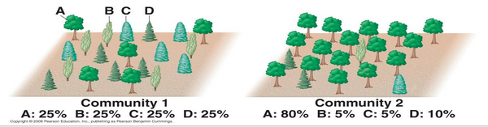

Do ecosystems change over time?

Ecological Succession
The change in the composition of species over time

Traditional view:
- One community with certain species is gradually and predictably replaced by another community of different species
- Species diversity and total biomass increase
- Climax community is attained at final stage… persists until destroyed by catastrophe (ex: fire)

Pioneer species: the plants and animals first to colonize a newly exposed habitat
- Typically opportunistic (r-selected), and can tolerate harsh conditions (ie: intense sunlight, arid climate, nutrient-deficient soil)
- Example: plants whose roots support nitrogen-fixing bacteria (mutualism)

Gradually, K-selected species replace r-selected species

Two kinds: Primary and Secondary Succession

Primary succession: substrate never had life before!
Example: Rock or lava
1) lichens
2) bacteria, protists, mosses, and fungi
3) insects and other arthropods
4) nitrogen fixing bacteria
5) grasses, weeds, herbs (r)
6) perennial shrubs and trees (K)

Secondary succession: substrate where community completely or partially destroyed by a disturbance (flood, deforestation..)
Example: lakes and ponds
1) body of water
2) marsh land
3) meadow
4) climax community of native vegetation (ie: part of the forest)

Try This
1. You survey two plots of trees. Plot 1 has six species of trees and 95% of all trees belong to just one species. Plot 2 has five different species of trees, each representing ~20%. How would you describe plot 2 compared to plot 1 in terms of tree species diversity, richness, and abundance?

2. During succession, inhibition by early species may have what consequence?

