Choose Your Own Adventure Geometry and Measurement
Concept 1: Geometry and Measurement
Beginning | Developing | Accomplished | Exemplary
Does not demonstrate a basic understanding of concept. Substantial errors throughout. | Basic understanding of concepts. Errors and inconsistency reveal some missing understanding of the concepts. | Solid understanding of concepts. Most answers are correct with only a few errors. | Complete and in depth understanding of concepts.
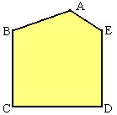
- Which line segments are parallel? Circle them in this picture:

- What word describes lines that intersect (cross) at 90°

- Angle bisector b) line segment c) perpendicular d) parallel

- Determine the area of the parallelogram shown. Area of a triangle = (bxh)÷2
Area of a rectangle = l x w

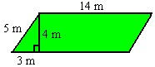

Choose Your Own Adventure Circles
Concept 2:Circles
Beginning | Developing | Accomplished | Exemplary
Does not demonstrate a basic understanding of concept. Substantial errors throughout. | Basic understanding of concepts. Errors and inconsistency reveal some missing understanding of the concepts. | Solid understanding of concepts. Most answers are correct with only a few errors. | Complete and in depth understanding of concepts.

Circumference = 2 л r or C = d Area = л r ²

- What is the diameter of the circle shown?
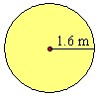

- What is the circumference of a circle with a radius of 3 m?

- What is the area of a circle with a diameter of 4 cm?

Concept 8: Integers
Beginning | Developing | Accomplished | Exemplary
Does not demonstrate a basic understanding of concept. Substantial errors throughout. | Basic understanding of concepts. Errors and inconsistency reveal some missing understanding of the concepts. | Solid understanding of concepts. Most answers are correct with only a few errors. | Complete and in depth understanding of concepts.

- If the shaded circles represent negatives, and the open circles represent positives, what is the answer to the following addition question?

- Subtract (–7) – (–8).

- Michel opened an ice-cream cart at the beach. During his first week, he gave away free samples, and lost $120. During the second week, he made a profit of $180. Determine Michel's total profit or loss over the first two weeks of operation.

- The temperature in Whitehorse, Yukon was –12º C at noon. By midnight, the temperature had dropped by 14º C. What was the temperature at midnight?

Concept 9: Patterns and Expressions
Beginning | Developing | Accomplished | Exemplary
Does not demonstrate a basic understanding of concept. Substantial errors throughout. | Basic understanding of concepts. Errors and inconsistency reveal some missing understanding of the concepts. | Solid understanding of concepts. Most answers are correct with only a few errors. | Complete and in depth understanding of concepts.

- A canoe rental at Crystal Lake Marina costs $10 plus $5 per hour. What is the cost of renting a canoe for 3 hours?

- Ben has b dollars in his bank account. Nelida has $10 less than twice as much. Write an expression (using numbers and variables) that models the amount in Nelida's account.

- Which table of values matches the graph
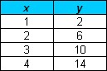
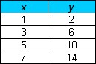

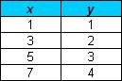
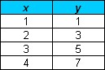
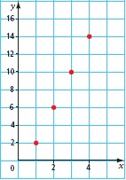

Concept 10 :Solving Equations
Beginning | Developing | Accomplished | Exemplary
Does not demonstrate a basic understanding of concept. Substantial errors throughout. | Basic understanding of concepts. Errors and inconsistency reveal some missing understanding of the concepts. | Solid understanding of concepts. Most answers are correct with only a few errors. | Complete and in depth understanding of concepts.

32. What is the solution to x – 2 = 5?

- Which of these equations has the solution a = 3?

- a + 1 = 2

- a + 1 = –2

- a – 1 = 2

- a + 2 = 1

- Jay is painting his cottage yellow with blue trim. He calculates that he needs 5 more cans of yellow than blue. He bought a total of 25 cans at the paint store. Let b represent the number of cans of blue paint. Which equation models this situation?

- b +b + 5 = 25

- b + 5b = 25

- b + 25b = 5

- 5b = 25

Concept 11 :Working with Data
Beginning | Developing | Accomplished | Exemplary
Does not demonstrate a basic understanding of concept. Substantial errors throughout. | Basic understanding of concepts. Errors and inconsistency reveal some missing understanding of the concepts. | Solid understanding of concepts. Most answers are correct with only a few errors. | Complete and in depth understanding of concepts.

- The number of contracts for the Heavy Rock Paving company each month for the past year are shown. What is the mean number of contracts per month?
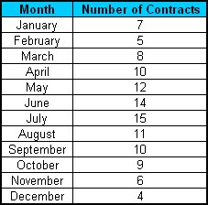

- What is the mode in the above data?

- The lowest value in a data set is 5.6. The range is 3.8. What is the highest value?

- Sunjay received a mean of 70% in mathematics. He recalled that four of his tests had marks of 70%, 72%, 78%, and 68%. What was the mark on the fifth test?

