Choose Your Own Adventure Graphs
Concept 1: Coordinates and Design
Beginning | Developing | Accomplished | Exemplary
Does not demonstrate a basic understanding of concept. Substantial errors throughout. | Basic understanding of concepts. Errors and inconsistency reveal some missing understanding of the concepts. | Solid understanding of concepts. Most answers are correct with only a few errors. | Complete and in depth understanding of concepts.

- What are the signs of the coordinates in quadrant III?
- (+, +) b) (-. -) c) (+. -) d) (-, +)

- Ivan plotted the following points on a coordinate grid: (1, 1), (2, 2), (3, 3), and (4, 4). (use the grid to plot the points if you’d like). These points lie on a line that goes through:
- the origin.
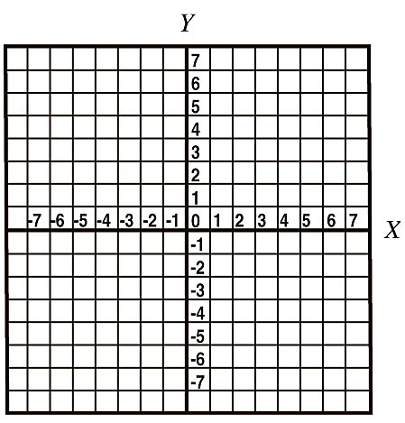
- the x-axis, but not the origin.
- the x-axis at (1, 0) and the y-axis at (0, 1).
I
II
- the y-axis, but not the origin

IV
III

- Draw and label the axes of a coordinate grid by 2s. Plot the following points: A (-5, 2), B (-4, 0), C(-2, -1), D (0, -3), E (1, -4), F (3, -6)
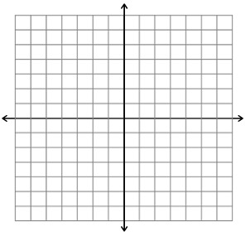

Choose Your Own Adventure Number Operations
Concept 2 : Operations of Decimal Numbers
Beginning | Developing | Accomplished | Exemplary
Does not demonstrate a basic understanding of concept. Substantial errors throughout. | Basic understanding of concepts. Errors and inconsistency reveal some missing understanding of the concepts. | Solid understanding of concepts. Most answers are correct with only a few errors. | Complete and in depth understanding of concepts.

Can you do the following questions without a calculator? Try!
- Calculate 4.85 + 0.5 – 3.2

- What is the value of the following expression?
3.12 x 4² + 12 ÷1.5 x 2

- Brady bought a ball of string. She found that she could cut it into either 5 or 9 equal pieces without a remainder. If she cuts it into 5 equal pieces, each piece is 3.69 m long. What is the length of each piece if she cuts the string into 9 equal pieces?

