Statistical Analysis
AP Biology 11

In order to determine if your data supported your hypothesis, you must determine whether the differences between you experimental and control are _______________________or are they the results of _________________________________________.

You Must Know: What is meant by degrees of freedom, critical value, the null hypothesis, and how to do a Chi-square analysis of data.

Chi-Square Test
This test is a type of ‘goodness of fit’ test.
Your experimental results are _________________to match the predicted results exactly but are the differences due to ______________alone or something else?

The Chi-Square tests how well the data fits the ____________________________.

The null hypothesis states that there is ____ statistically significant __________________between the experimental and expected results.
The null hypothesis is a hypothesis which the researcher tries to disprove, reject or _______.

Example of the Null Hypothesis:

A researcher may postulate a hypothesis:
H1: Tomato plants exhibit a higher rate of growth when planted in compost rather than in soil.

And a null hypothesis:
H0: Tomato plants do not exhibit a higher rate of growth when planted in compost rather than soil.
When there is little difference between the observed results and the expected results, you obtain a very low Chi-square values; your hypothesis is_______________!

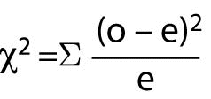

o =

e =

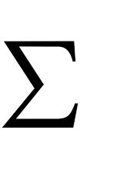

Degrees of Freedom: this number is ______________than the total number choices in your experiment
df =

Probability value (p): Deviations having a chance probability greater than 0.05 (5%) __________support the null hypothesis. Therefore, you should consult the table for the p value in the 0.05 row

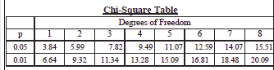

How to do an Analysis:

1. Set up a __________(p. 328 Holtzclaw)

2. Determine the _________________

3. Find the probability (p) value for the number of degrees of freedom in the ________row.
This is the____________________.

4. Accept or Reject the ___________ hypothesis.
If the Chi-square value is greater than the critical value, the null hypothesis is rejected!

Example

H_{A} : If pill buys are given a choice between moist and dry environments, they will have a preference for the moist because they need a moist environment for respiration

Ho: If pill bugs are given a choice between moist and dry environments, they will have no preference

Observed Data: 7 bugs on moist and 3 bugs on dry
Expected Data: 5 bugs on moist and 5 on dry

