Unit: Cellular Respiration and Photosynthesis
Concept 1: Analyzing the Processes of Cellular Respiration

Concept 1: You Must Know….

The summary equation of cellular respiration.
The difference between fermentation and cellular respiration.
The role of glycolysis in oxidizing glucose to two molecules of pyruvate
The process that brings pyruvate from the cytosol into the mitochondria and introduces it into the citric acid cycle
How the process of chemiosmosis utilizes the electrons from NADH and FADH2 to produce ATP

How is cellular metabolism relevant to higher levels of biological organization: physiology (breathing, digestion), ecology (communities)?

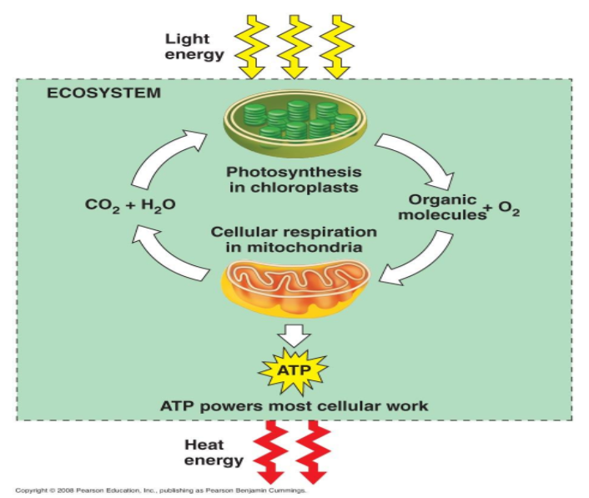

Cellular Respiration
Catabolic - __________________ complex molecules into smaller ones

Exergonic - __________________that can be used to do work (such as build ATP from ADP and Pi)

There are 2 catabolic pathways that you need to know:

Fermentation - the partial degradation of sugars that occurs __________________ the use of oxygen

Cellular Respiration - the most prevalent and efficient catabolic pathway. It is also called _______________________ since oxygen is required as fuel.

Your mitochondria use a series of controlled steps, releasing energy in _____________________ at a time
- Some energy is still lost as heat
- The rest is converted to chemical energy in ATP for use in the cell
- This is done through a series of Redox reactions

Reduction/Oxidation Reactions
Redox Reactions - Follows the movement of ELECTRONS from one chemical to another

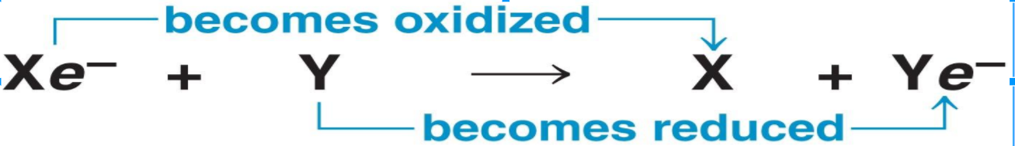

“X” is ____________ electrons
“Y” is ____________ electrons

Redox and Cellular Respiration:

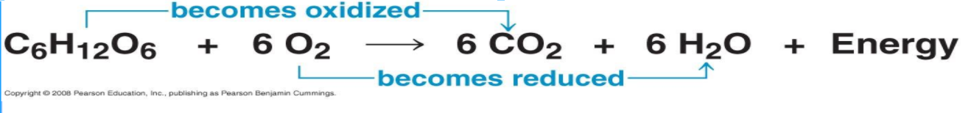

Electron Carriers

- NAD⁺ is a __________________ electron carrier (nicotinamide adenine dinucleotide – a derivative of the vitamin niacin)

NAD⁺ + 2e ⁻ + H⁺ produces NADH So….is NAD⁺ reduced or oxidized?

- FAD, a coenzyme ________________. FAD + 2e ⁻ + 2H ⁺ produces FADH₂

An Overview of Cellular Respiration: Cellular respiration has three stages
- Glycolysis (breaks down glucose into two molecules of pyruvate)
- The citric acid cycle (completes the breakdown of glucose)
- Oxidative phosphorylation (accounts for most of the ATP synthesis)

