AP Biology 12
Concept 4: Cell Communication

You must know:
- The three stages of cell communication: reception, transduction, and response (the signal transduction pathway!)
- Applications/Examples
  - How G protein-coupled receptors, receptor tyrosine kinases, ligand-gated ion channels, and intracellular receptors receive cell signals and start transduction
  - How a cell signal is amplified by a phosphorylation cascade, via second messengers (such as cAMP or Ca²⁺ ions) and protein kinases.
  - How a cell response in the nucleus turns on genes, whereas in the cytoplasm it activates enzymes
  - What apoptosis means and why it is important to normal functioning of multicellular organisms

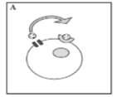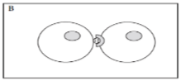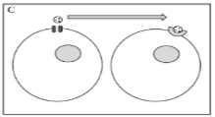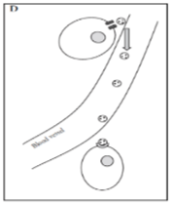
In picture A, label the following: cell, ligand, receptor, membrane channel.

Which diagram depicts communication between cells that are in close proximity?

Which diagram depicts long distance communication between cells?

In which type of communication would the ligand need to have the longest “life”?

Communication between cells is just as important as it is in our lives. Trillions of cells need to coordinate their activities to develop from fertilized egg, to survive and to reproduce.

Cell Communication is just like…..

Cells are close to other cells:
Example: plants have plasmodesmata or gap junctions in animal cells

Specific recipient:
Example: neurotransmitter through a synapse

Message goes to all cells:
Example: is hormone HGH

Another Example: Viagra

A common ______________signaling pathway leads to dilation of blood vessels. Once the signal subsides, the response is shut down the enzyme shown in purple. Viagra is an _____________compound. Most cells communicate with each other chemically like in this example but some are light and touch

Signal Transduction Pathway
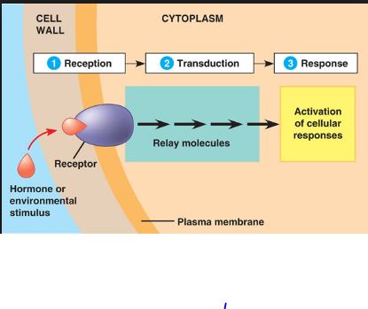

1. Reception - The target cell’s detection of a
__________ molecule coming from outside the cell.

Receptors undergo changes in __________ due to an
environmental stimulus

Membrane Receptor Examples:

a) G Protein-Coupled Receptors

Step 1:

Step 2: The ligand binds to the G protein-coupled receptor. This causes a __________________ in the receptor. Receptor binds to an inactive G protein, causing ___________to displace the phosphate. This activates the G protein

Step 3: The G protein binds to a specific _______________ and activates it. When the enzyme is activated, it can trigger the next step in a _______________, leading to a cellular response.

Step 4: All molecular shape changes are ______________. To continue the cellular response, new signal molecules are required.

b) Receptor Tyrosine Kinases

A kinase is an enzyme that catalyzes the transfer of ________________groups from ATP to the amino acid tyrosine. One receptor tyrosine kinase complex may _________________10 or more different transduction pathways and cellular responses.

The receptor tyrosine kinases are a type of_________________ protein.

Steps 1 & 2: Signal molecules bind to the receptors and forms a dimer. In the ___________________configuration each tyrosine kinase adds a phosphate from an ATP molecule.

Steps 3 & 4: The fully activated receptor protein initiates a __________________________for each phosphorylated tyrosine.
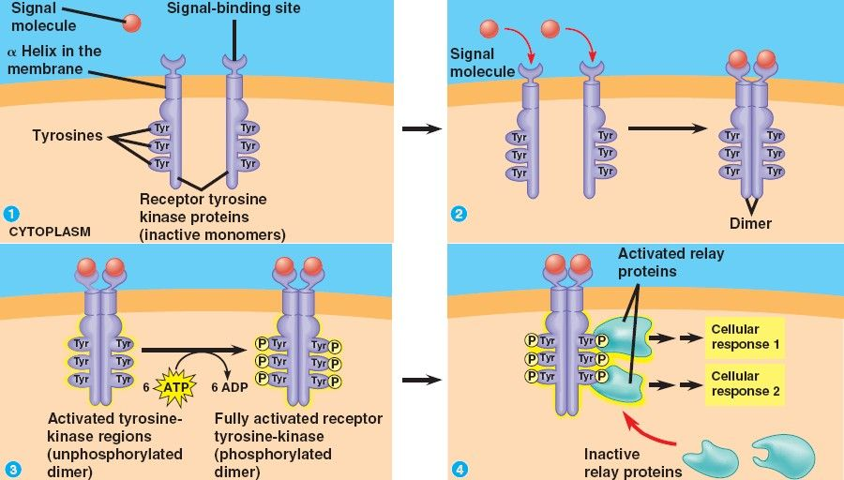

c) Ion Channel Receptors
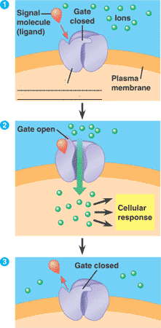

Specific signal molecules cause ________________ion channels in a membrane to open
or close, regulating the flow of specific ions.

2) Transduction - The conversion of the signal to a form that can bring about a _________
cellular response. ___________________of signal through a multistep pathway.
Allows small signal to produce large cellular response

a) Phosphorylation cascades.
These often involve a__________________________. Because the pathway is usually a multistep one, the possibility of greatly amplifying the signal exists.
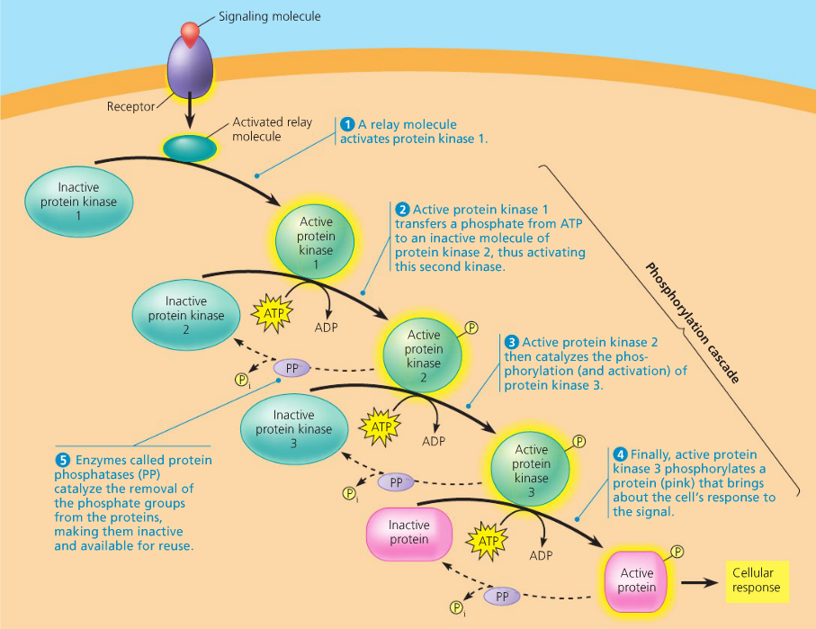

At each step, enzymes called _________________phosphorylates and thereby activate many proteins at the next level. This cascade enhances the signal, allowing for a ______________ cellular response. _____________________ are enzymes that remove phosphate groups and inactive protein kinases. Thus, the signal can be turned on by kinases and off by phosphates.
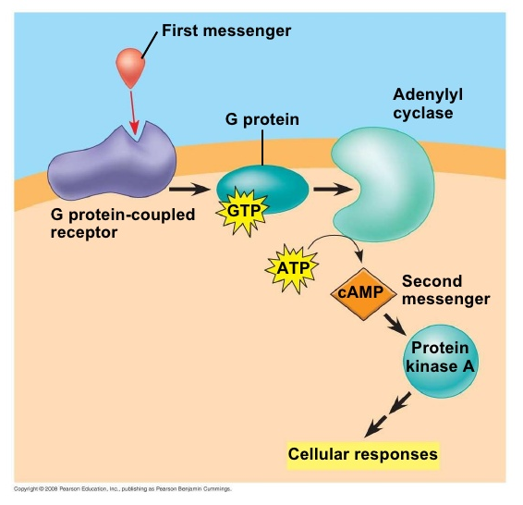
b) Cyclic AMP - a second messenger.

Many components involve small, ______________water-soluble molecules or ions called
second messengers.
Example: Calcium ion and cyclic AMP
The _____________________, once activated, can initiate a phosphorylation cascade
resulting in cellular response.

3. Response: The specific cellular response to the signal molecule.

Two ways response is accomplished:

- Transcriptional Modification:
↑ or ↓ mRNA production (turning genes on/off)

Many signalling pathways ultimately regulate___________________, usually by turning specific genes on or off in the nucleus.

- Post-Translational Modification:
Activates existing enzyme molecules

In the cytoplasm, pathways regulate the ______________ of proteins rather than their synthesis.

For example: the final step in the signaling pathway may affect the activity of enzymes or cause __________________ rearrangement.

Apoptosis: Cell suicide.

This protects ______________________cells from damage that would occur if a dying cell merely leaked out its digestive and other enzymes.
Apoptosis is triggered by signals that activate a cascade of ‘suicide’ proteins in the cells. Part of the _______________________

