**AP Biology: Bacteria and Archaea**

**Concept 2: Analyzing the diversity of bacteria, archaea, protists and fungi**

Chapters 26, 27, 28, 31

*You must know:*

* The key ways in which prokaryotes differ from eukaryotes with respect to genome, membrane-bound organelles, size, and reproduction.
* Mechanisms that contribute to genetic diversity in prokaryotes, including transformation, conjugation, transduction, and mutation.

*Refer to pg 174-176 in Holtzclaw, Ch 27 in Campbell*

The Prokaryote:

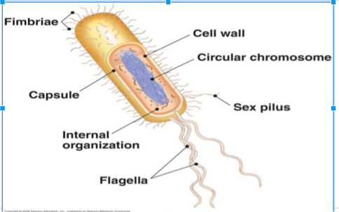



What are plasmids?

**Prokaryotes versus Eukaryotes**

|  |  |  |
| --- | --- | --- |
|  | **Prokaryotes** | **Eukaryotes** |
| Genome |  |  |
| Membrane-Bound Organelles |  |  |
| Size |  |  |
| Reproduction |  |  |

What is the difference between these three domains? Refer to p. 174 Holtzclaw

**“A Comparison of the three domains of Life”**

|  |  |  |  |
| --- | --- | --- | --- |
| **Characteristic** | **Bacteria** | **Archaea** | **Eukarya** |
| Nuclear Envelope |  |  |  |
| Membrane-enclosed organelles |  |  |  |
| Introns |  |  |  |
| Histone proteins associated with DNA |  |  |  |
| Circular chromosome |  |  |  |

**Genetic Diversity in Prokaryotes**

Asexual Reproduction

* Need mechanisms to contribute to genetic diversity
  + WHY?

Examples of Asexual Reproduction

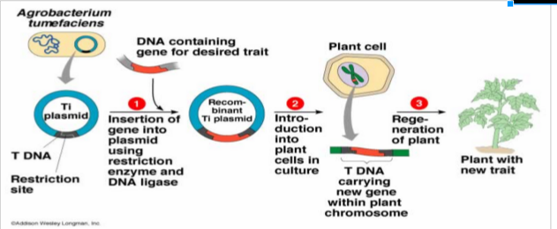

Mechanisms for Genetic Diversity

* Mutation (with rapid reproduction)

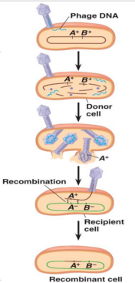

* Transformation
* Conjugation
* Transduction

Write an example/notes for each of the following:

* Chemical Recycling – Decomposers
* Ecological Interactions – Symbiosis
  + Mutualism
  + Bioremediation
  + Your intestinal bacteria
  + Production of cheese, etc
  + Deep-sea vents
  + Commensalism
  + Parasitism
    - Pathogenic
  + Antibiotics

What causes antibacterial resistance?

**Concept 2: Analyzing the diversity of bacteria, archaea, protists, and fungi   
(Ch 26, 27, 28, 31)**