AP Biology: Homeostasis
Concept 4: Analyzing how hormones in the animal endocrine system use feedback to control homeostasis (Ch 40, 45)

You must know:
- The importance of homeostasis and examples
- How feedback systems control homeostasis
- One example of positive feedback and one example of negative feedback.

Exchange with the Environment
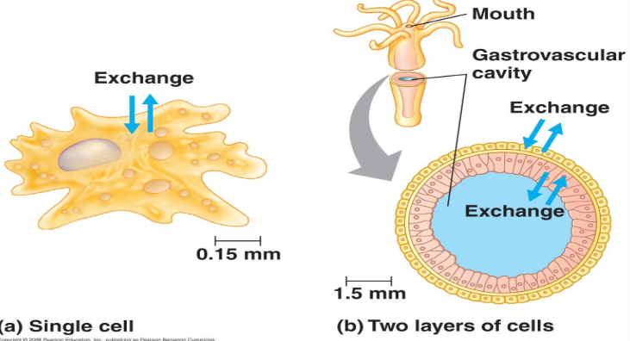
Animals need to exchange materials with their ______________& this poses limitations to_______________.

The rate of exchange is proportional to membrane surface area.

The amount of material that must be exchanged to sustain life is also proportional to volume.

hierarchical organization of body plans

Cells: form an animal’s body through their emergent properties.
Tissues: groups of cells of similar appearance and a common function.
Organs: Different tissues are organized into functional units called organs.
Organ Systems: groups of organs that work together.

TISSUE TYPES
- Epithelial Tissue - Occur in sheets of cells, covers the ____________of the body and lines organs and cavities _____________the body.
- Connective Tissue - The most common function is to _________and _________other tissues in the body
- Muscle Tissue - Responsible for nearly all types of body_________. All contain _______and________.
- Nervous Tissue - The function is to ____________stimuli and transmit signals in the form of______________.
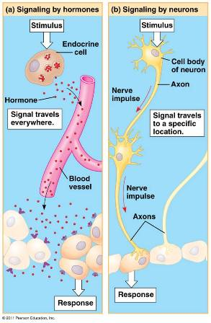
CONTROL & COORDINATION Two major systems control and coordinate animal tissues, organs, and organ systems:
Endocrine System - (using ___________that travel via blood)
Nervous Systems (using impulses along nerves and _______________between nerves)
HOMEOSTASIS
In homeostasis, animals maintain a relatively______________________, even when the external environment changes significantly.

  - Temperature
  - pH
  - Salinity

FEEDBACK SYSTEMS CONTROL
Negative (opposite) Feedback Systems
  - Animal response reduces stimulus
Example:

Positive (same) Feedback Systems
  - Animal response amplifies the change (instead of reversing it)
Example:

Energy requirements are related to animal size, activity and environment
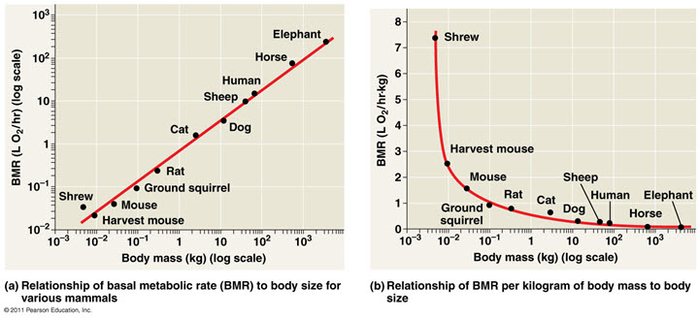

Basal Metabolic Rate (BMR) - minimum metabolic rate of a non growing __________________that is at rest, has an empty stomach and is not experiencing stress.
Standard Metabolic Rate (SMR) - the metabolic rate of a fasting, non-stressed _________________at rest at a particular temperature

Torpor and Energy Conservation
Torpor → a physiological state in which activity is low and metabolism decreases is an ________________to conserve energy during environmental extremes.
Example:

