AP Biology: The Endocrine System
Concept 4: Analyzing how hormones in the animal endocrine system use feedback systems to control homeostasis (ch 40, 45)

Two major systems control and coordinate animal tissues, organs, and organ systems:
- Endocrine System (using _______________that travel via blood)
- Nervous Systems (using impulses along nerves and _____________________between nerves)

Pituitary Gland

Anterior Pituitary – a _________endocrine gland
1. Cells in the ________________produce ________________hormones (such as GnRH and TRH).

2. These hormones are secreted into the _______________and travel to _________cells in the anterior pituitary
3. The anterior pituitary produces and releases a _____________hormone to the __________(such as LH, FSH and TSH).
Posterior Pituitary (an ___________growth of the hypothalamus)

1. The ______________produces some hormones that are stored in the _____________of the posterior pituitary.
2. The posterior pituitary releases these hormones when____________.

___________Feedback – Breastfeeding and oxytocin
___________Feedback – thyroxin
Maintaining Homeostasis – Insulin and Glucagon Uses __________feedback
Adrenal gland Cortex – hormonal control –__________________

Medulla – nervous control – _________________

Reproductive Hormones
Hormones make it happen
Days | Ovarian Cycle | Uterine Cycle
1  5 | Follicular Phase  - development of follicle | Menstruation  - shedding of endometrium
6  13 |  | Proliferation Phase  -endometrium develops and thickens
14 | Ovulation- ovum is released
15  28 | Luteal Phase  - development of corpus luteum | Secretory Phase  - endometrium thickens, secretes mucus, becomes vascularized
Cycle will repeat if not pregnant

The Female Key Players….
GnRH: _________-releasing hormone

FSH: __________stimulating hormone

LH: __________hormone
The hormone oxytocin: another example of a positive feedback loop!
1) Childbirth
- Fetus reaches cervix
- cervix sends nerve impulses to the hypothalamus
- oxytocin is produced in the hypothalamus
- oxytocin is stored and released by the posterior pituitary gland
- oxytocin is carried by blood
- oxytocin causes an increase in uterine contractions
- Contractions cause fetus to push against the cervix

2) Breastfeeding
- suckling by infant stimulates the nerves in the breast
- nerve impulses sent to hypothalamus
- oxytocin is produced in the hypothalamus
- oxytocin is stored and released by the posterior pituitary gland
- oxytocin is carried by blood
- oxytocin causes muscles in mammary glands to squeeze out milk
- infant suckles to get milk
When? | What type of feedback? | Hormones involved? | Steps of what happens:
During follicular phase:
During luteal phase:
After implantation
During childbirth
During breastfeeding

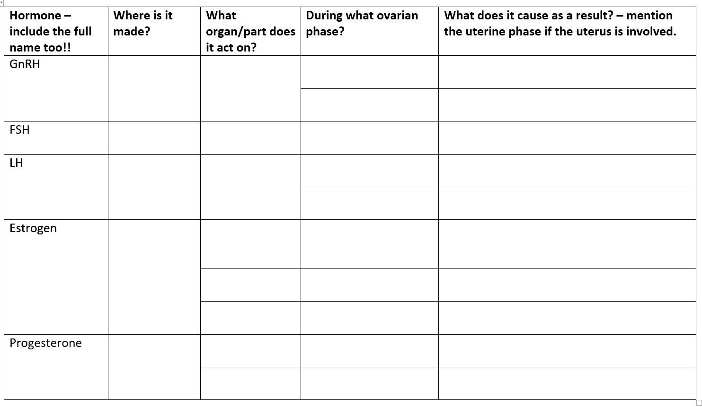

Male Reproduction: Hormones
1. Describe the functions of testosterone:
- Development and function of male reproductive organs (_____________)
- Secondary role is ___________

The homeostatic regulation of testosterone levels by the hypothalamus, anterior pituitary, and testes
Testosterone and sperm production is maintained at a steady level by _________feedback.

if testosterone levels are too LOW:

- The hypothalamus secretes GnRH.
- The anterior pituitary secretes LH and FSH
- Because _____________LH, the interstitial cells in the testes secrete __________testosterone.
- Because of _________FSH and testosterone, the seminiferous tubules in the testes produce ______sperm.

If testosterone levels are too HIGH:

- The hypothalamus secretes _______GnRH.
- The anterior pituitary secretes ______LH and ________FSH
- Because of ________LH, the interstitial cells in the testes secrete _______testosterone.
- Because of _________FSH and testosterone, the seminiferous tubules in the testes produce _______sperm.

