AP Biology 12 – Enzyme Lab Day 1

Baseline is a universal term for most chemical reactions. We will use it to establish a standard for a reaction. It is a reference to help us understand what occurred in a reaction after we manipulate components such as substrates and enzymes. Different conditions can be compared and the effects of changing an environmental variable such as pH can be determined.
Reaction Rate. When comparing the change in a reaction, you can infer increase, decrease or no change in the rate of a product being produced. This is called the relative rate of the reaction. To measure the actual volume and time during a reaction, this is referred to as absolute rate of the reaction, ie. 97 mL per minute.

Day 1 Goal:
1. To establish a Baseline for Hydrogen Peroxide - H₂O₂ with and without a catalyst.
2. To propose an experiment for day 2
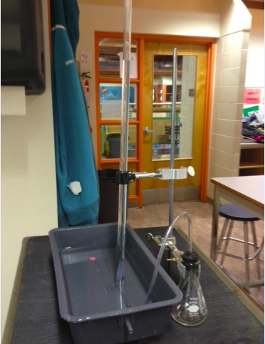
Apparatus:

Reaction: 2 H₂O₂ 2H₂O + O₂
Procedure Day 1 – Establishing a Baseline
Experiment 1: Decomposition with a Catalase
- Set up apparatus.
- Create a data table to record volumes of gas collected and time.
- Put in 10mL H₂O₂ into flask and 1 mL Catalase.
- Collect the gas and time how long it takes to reach a specific volume.

Experiment 2: Decomposition without Catalase
- Set up apparatus.
- Create a data table to record volumes of gas collected and time.
- Put in 10mL H₂O₂ into flask and 1 mL H₂O (to keep volume constant).
- Collect the gas and time how long it takes to reach a specific volume.

