AP Biology 12 - Concept 1: Analyzing the regulation of gene expression
Regulation of Gene Expression – Refer to pg 128-132 in Holtzclaw, Ch 18 in Campbell
o The functions of the three parts of an operon
o The role of repressor genes in operons
o The impact of DNA methylation and histone acetylation on gene expression
o The roles of oncogenes, proto-oncogenes, and tumor suppressor genes in cancer

What Causes Cancer?
Types of Cells
Oncogenes →
Proto-oncogenes →

Proto-oncogenes____________________oncogenes when a mutation occurs that causes an increase in the _____________of the proto-oncogene, or an increase in the _________________of each protein molecule produced by the gene

Cancer can be caused by a mutation in a gene whose products normally inhibit cell division.
There are 3 ways this can happen through genetic change….
- Translocation → Cancer cells are frequently found to contain chromosomes that have broken and rejoined incorrectly → _____________________________________________________________
If a translocated proto-oncogene ends up near an especially active promoter (or other control element), its transcription may increase, making it an oncogene.
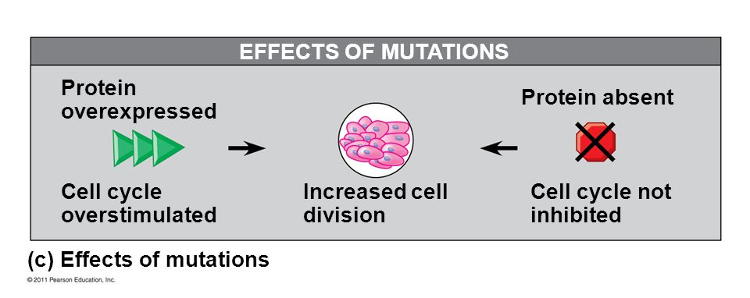

2. Amplification → increases the number of copies of the proto-oncogene in the cell

3. Point mutation in:
- the promoter or enhancer region causing increased expression OR
- the coding sequence, changing the gene’s product to a protein that is more active or more resistant to degradation than normal.
Cancer can also be caused by a mutation in the tumor-suppressor genes.
Example: p53 gene this gene’s product suppresses proteins in 4 different ways:
- p53 protein activate the p21 gene, whose product halts the cell cycle by binding to cyclin-dependant kinases. This allows ____________ for DNA to repair before resuming the cell cycle.
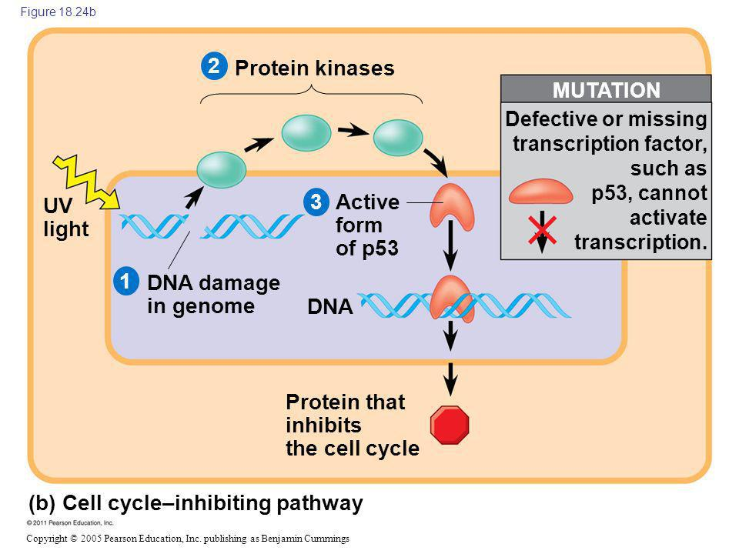

2. The p53 protein activates a group of miRNAs, which inhibit the cell cycle. Remember.. a micro RNA (miRNA) silences ____________ and post-transcription gene expression
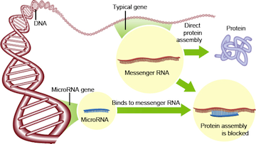
3. The p53 protein turns on genes directly involved in DNA repair.
4. When DNA damage is too great to repair, the p53 protein activates ‘suicide’ genes whose products cause cell death → apoptosis
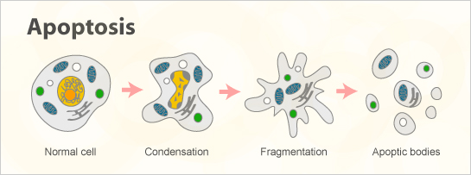

The multistep model of cancer development is based on the idea that cancer results from the___________________ of mutations that occur throughout life.
Embryonic development represents what happens when gene regulation proceeds________________ and cancer show what can happen when gene regulation goes awry.
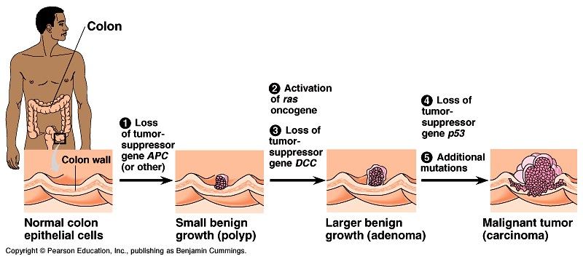

HOMEWORK:
Read page 366-378 in Campbell & p 132-134 in Holtzclaw focusing on embryonic development and cancer.
Questions: #1, 3, 4, 6, 7, 8, 11, 18-28, 30, 33 on page 143-147 in Holtzclaw

