AP Biology 12
Biotechnology

You must know:
- The terminology of biotechnology
- The steps in gene cloning with special attention to the biotechnology tools that make cloning possible
- The key ideas that make PCR possible
- How gel electrophoresis can be used to separate DNA fragments or protein molecule
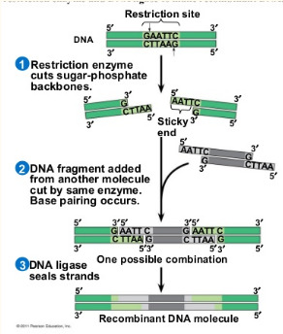
Using Restriction Enzymes to Make Recombinant DNA

Cloning and genetic engineering rely on ________________________________.
Hundreds of different restriction enzymes have been identified and isolated.
Each is very ________________ to a particular short DNA sequence,
or _______________________and cutting both DNA strands at precise points
within the restriction site.

DNA of bacterial cells is protected from the cells own restriction enzymes by the
addition of ________________ to adenines or cytosines within the sequences
recognized by the enzyme.
Most restriction enzymes recognizes sequences containing four to eight
nucleotides, because this is short is usually occurs _____________________in a
DNA molecule and a restriction enzyme will make many cuts, giving us ________________________.

The most useful restriction enzymes cleave the sugar-phosphate backbone in the two DNA strands in a staggered manner, theses produce a _________________.
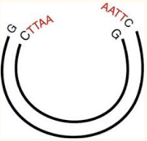
The sticky ends will form __________________________base pairs with complementary sticky ends on any other DNA molecules cut with the same enzyme. They matches then becomes permanent with the help of _______________________.

Application

Create a restriction map for the plasmid pGEN 101 (total length is 20kb). When digested with EcoRI (a restriction enzyme), one linear fragment results. Digestion with BamHI results in 3 fragments of the following sizes: 12kb, 2kb, 6kb. A combination digest with EcoRI and BamHI results in 4 fragments: 8kb, 4kb, 2kb and 6kb.

Digest performed Size of fragments obtained

EcoRI __________
BamHI __________
EcoRI + BamHI __________

Gel Electrophoresis

Often, in order to study DNA, we need to use a gel electrophoresis. The technique uses a gel to _____________ nucleic acids or proteins on the basis of __________ and ________________________.

DNA carries a ________________________ charge on their phosphate group so they travel toward the positive pole in an electric field. The gel impedes the ____________________ molecules more than the shorter ones, separating them by length.
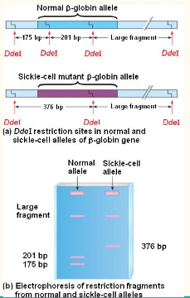

Restriction fragment analysis

DNA fragments produced by restriction enzyme digestion are are sorted
by gel electrophoresis. Useful for ________________ two different
DNA molecules ie. two alleles of a gene.
Example: Sickle cell destroys one of the DdeI restriction sites in the gene.
As a result, digestion with the DdeI enzyme generate _________________
from the normal and sickle-cell alleles.

Practice
Below is a plasmid with restriction sites for BamHI and EcoRI. Several restriction digests were done using these two enzymes either alone or in combination.
HINT: Begin by determining the number and size of the fragments produced with each enzyme.
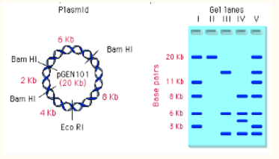
Which lane shows a digest with BamHI only?

Which land shows a digest with both BamHI and EcoRI?

Polymerase chain reaction (PCR)

PCR is a method used to _____________a particular piece of DNA without the use of cells. PCR is used when the source is impure (as it would be in a crime scene).

- Heat is used to_________ and separate the DNA
- Cooling allows primers to form hydrogen bond with ends of ________sequences
- DNA______adds nucleotides to the 3’ end of each primer

This results in thousands or millions of __________ of DNA sequence for diagnosis and monitoring of genetic diseases
