AP Biology 12 – Cellular Respiration and Photosynthesis Name:__________________
Concept 2: Analyzing the Processes of Photosynthesis Date:_____________________
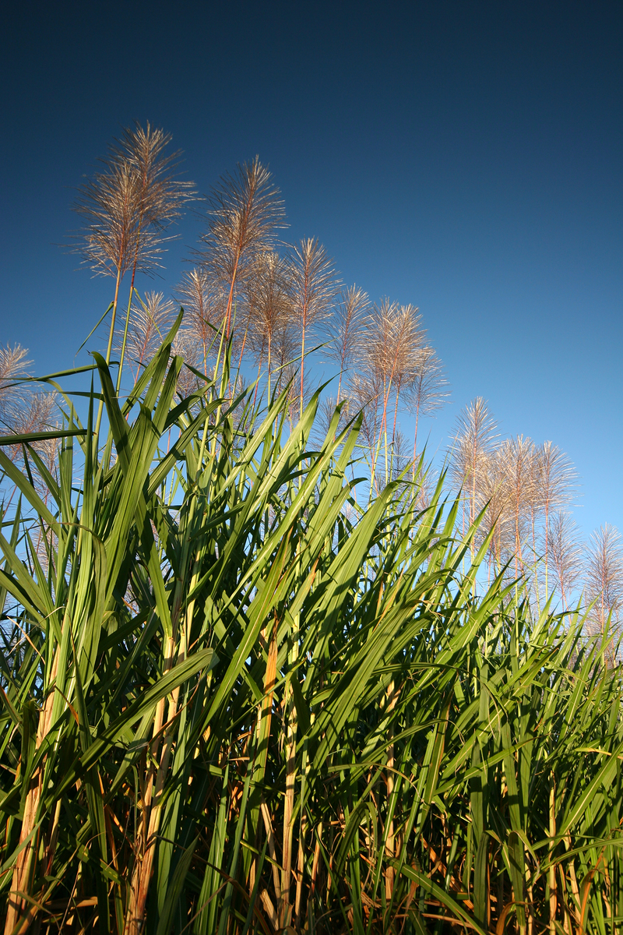
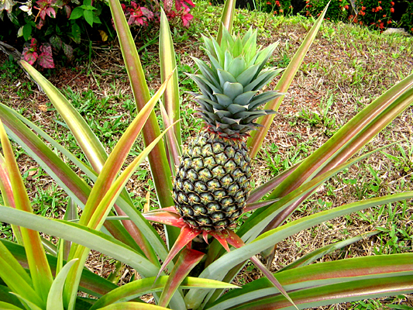
- The metabolic adaptations of C₄ and CAM plants to arid, dry regions Bl:____

Sugarcane – C₄ plant Pineapple – CAM plant
- Define carbon fixation.

- Explain the function of the enzyme rubisco.
- Define photorespiration.
- Why are C₃ plants not well adapted to arid, dry regions?
- Explain how C₄ plants are adapted to avoid photorespiration.
- Explain how CAM plants are adapted to avoid photorespiration.
- Explain the main similarity in C₄ and CAM adaptations.
- Explain the main difference in C₄ and CAM adaptations.
Ensure you can answer all questions in Holtzclaw on photosynthesis (and cellular respiration) ☺



