AP Biology – Science Practices Review Name:_______________ Date:______________  
  
*Answer the following examples questions and indicate whether which big idea they represent (evolution, free energy, information, or systems)*

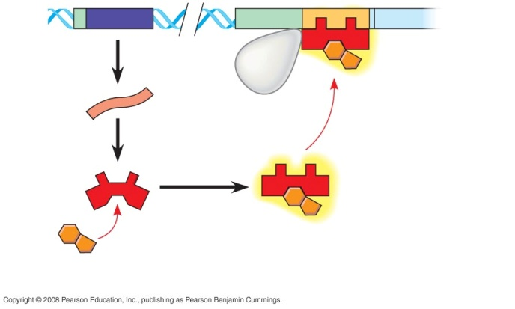**Science Practice 1: The student can use representations and models to communicate scientific phenomena and solve scientific problems.**a) Label the repressor protein in the diagram, indicating the *active* and *inactive* forms.

b) Is this repressor protein for an inducible operon or a repressible operon?

BIG IDEA(s): _____________________

**Science Practice 2: The student can use mathematics appropriately.**

A true-breeding green-seed pea plant was crossed with a true-breeding yellow-seed plant, producing an F1 generation that was all green-seeded. In the F2 generation, 351 plants had green-seeds and 110 had yellow seeds. Use chi square statistical analysis to determine if this example supports the idea that the mode of inheritance for seed colour in peas is complete dominance.   
  
BIG IDEA(s): _____________________

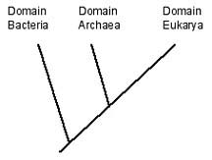**Science Practice 3: The student can engage in scientific questioning to extend thinking or to guide investigations within the context of the AP course.**

What scientific questions can you ask based on the phylogenetic tree shown?

BIG IDEA(s): _____________________

**Science Practice 4: The student can plan and implement data collection strategies appropriately to a particular scientific question.**

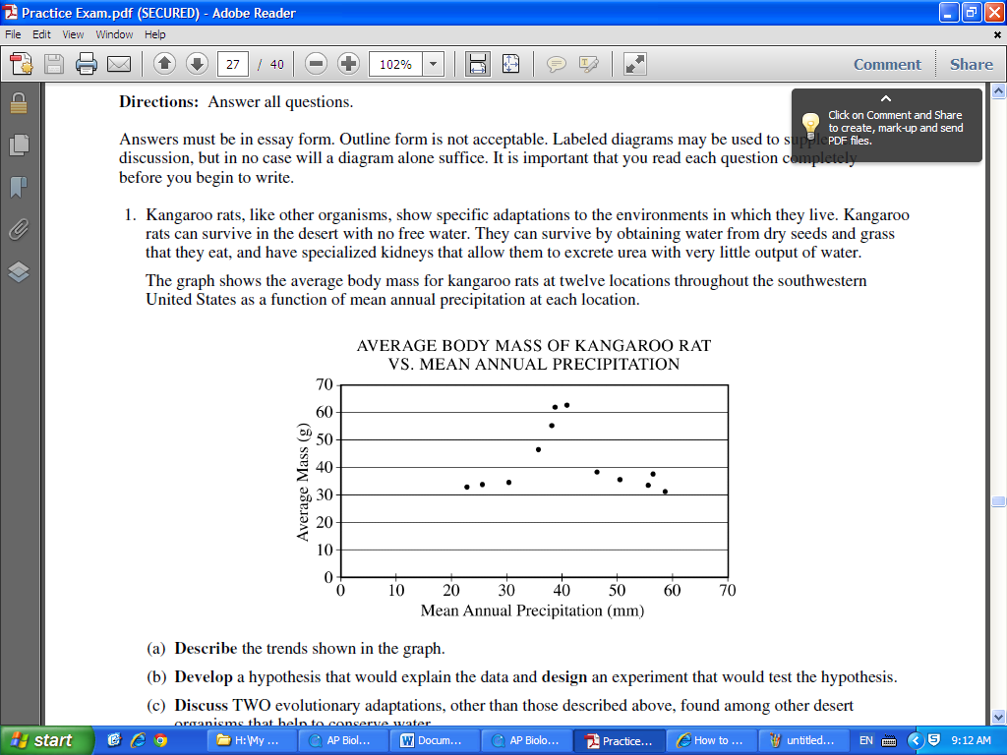

BIG IDEA(s): _____________________

**Science Practice 5: The student can perform data analysis and evaluation of evidence.**

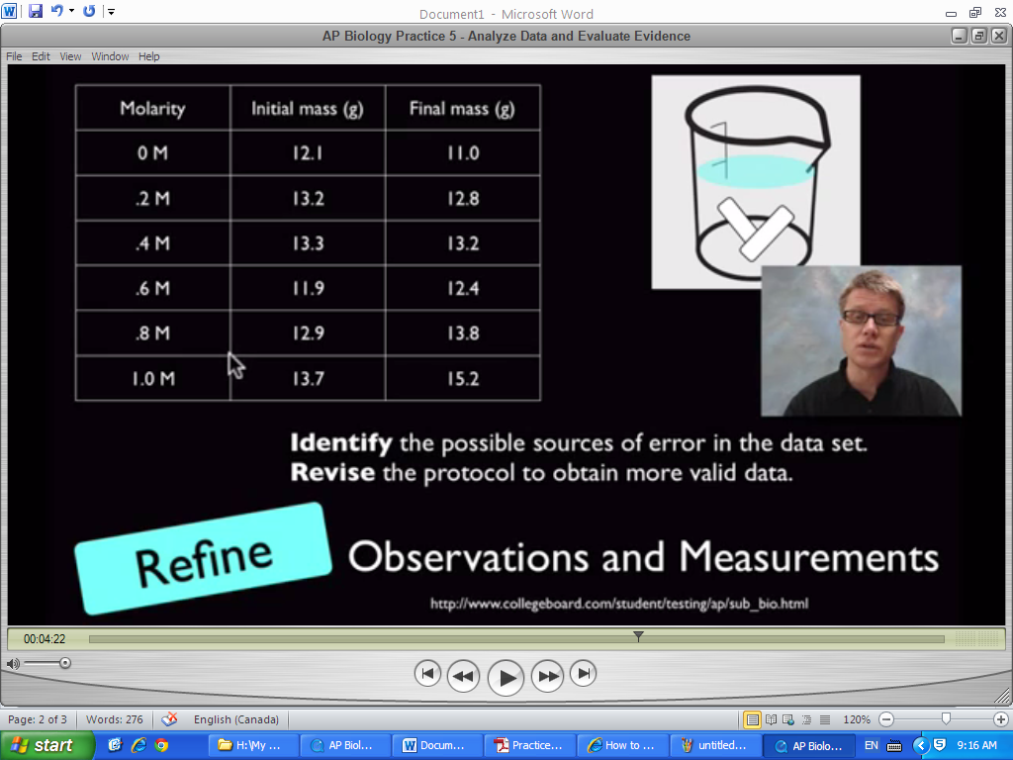  
*Source: Bozeman Biology YouTube Channel (Scientific Practices 5 video)*

BIG IDEA(s): _____________________

Science Practice 6: The students can work with scientific explanations and theories.  
  
BIG IDEA(s): _____________________

**Science Practice 7: The student is able to connect and relate knowledge across various scales, concepts and representation in and across domains.**

The endocrine system incorporates feedback mechanisms that maintain homeostasis. Which of the following demonstrates negative feedback by the endocrine system?

* 1. During labor, the fetus exerts pressure on the uterine wall, inducing the production of oxytocin, which stimulates uterine wall contraction. The contractions cause the fetus to further push on the wall, increasing the production of oxytocin.
  2. After a meal, blood glucose levels become elevated, stimulating beta cells of the pancreas to release insulin into the blood. Excess glucose is then converted to glycogen in the liver, reducing blood glucose levels.
  3. At high elevation, atmospheric oxygen is more scarce. In response to signals that oxygen is low, the brain decreases an individual’s rate of respiration to compensate for the difference.
  4. A transcription factor binds to the regulatory region of a gene, blocking the binding of another transcription factor required for expression.

BIG IDEA(s): _____________________