MACROMOLECULES
Concept 1: Analyzing and the chemistry of life (Ch 2, 3, 4, 5)
Ch 5 in Campbell p. 38-42 in Holtzclaw

How proteins reach their final shape (conformation), the denaturing impact that heat and pH scale can have on protein structure, and how these changes may affect the organism.
You must know:
- You must know:
- The role of dehydration synthesis in the formation of organic compounds and hydrolysis in the digestion of organic compound
- How to recognize the four biologically important organic compounds (carbohydrates, lipids, proteins, and nucleic acids) by their structural formulas.
- The cellular functions of all four organic compounds.
- The four structural levels that proteins and how changes at any level can affect the activity of the protein.
- How proteins reach their final shape (conformation), the denaturing impact that heat and pH scale can have on protein structure, and how these changes may affect the organism.

Two important biochemical reactions:
- Dehydration Synthesis
- Hydrolysis
Dehydration Synthesis
Dehydration synthesis creates a longer _____________ by ___________________________________
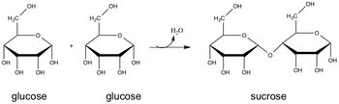

Example:
Hydrolysis
A hydrolysis reaction creates ______________ by _________________________________
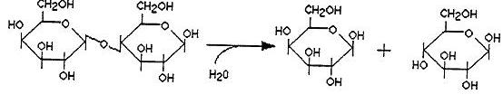

Example:

Try This
How many molecules of water are needed to completely hydrolyze a polymer that is eight monomers long?

Four Types of Organic Compounds
- Carbohydrates
- Lipids
- Nucleic Acids
- Proteins

Carbohydrates
Structure –

Disaccharides and polysaccharides are formed through _________________reactions

Example:

Cellular Functions:
Lipids
Structure - a fat is made up of a _________________and a ____________________.
__________________reactions synthesis fats

Examples:

Structure | Function

Nucleic Acids
Structure- nucleic acids are made of ___________________. A nucleotide is a __________, a _____________ and a __________________.

Cellular Function – The Central Dogma!
1.
2.
3.
Proteins
Structure – Proteins are ______________ made of _____________.
They are formed by ____________________synthesis.

Four structural levels
- Primary

- Secondary

- Tertiary

- Quaternary

Cellular Function

Denaturing:

Try This! (True or False?)
1. Primary protein structure is stabilized by peptide bonds between a linear sequence of amino acids.
1. Primary protein structure is stabilized by peptide bonds between a linear sequence of amino acids.
2. Secondary protein structure is stabilized by hydrogen bonds between R groups on adjacent amino acids.
3. Both primary and tertiary protein structure may be stabilized by covalent bonds.
4. All proteins display primary, secondary, and tertiary levels of protein structure.

Try This! (Matching)

Levels of protein structure Interactions

1. Primary a. Interactions between R groups

2. Secondary structure b. Hydrogen bonds between constituents of the polypeptide backbone

3. Tertiary structure c. Aggregations between polypeptides

4. Quaternary structure d. Peptide bonds

