Pre AP Biology 11: Creating Chains and Webs to Model Ecological Relationships
Overview
This hands-on activity supports the HHMI short film The Guide and the 2015 Holiday Lectures on Science: Patterns and Processes in Ecology. You will identify producers and consumers in the savanna ecosystem of Gorongosa National Park in Mozambique. Using a set of “Gorongosa cards,” you will then create a food chain to show the flow of energy in that system, introduce an ecological force or disturbance (e.g., fire), and predict how that force would impact energy flow. Lastly, you will construct a more complex model of the flow of energy by depicting multiple relationships in a food web and again make a prediction about the impact of introducing an ecological force.

Instructions
All food chains start with a producer such as a plant, which converts light energy from the sun into a more useable chemical energy that is transferred to herbivores and then to carnivores. You will receive a set of cards that depict some common animals, plant types, and ecological forces or disturbances from the savanna ecosystem in Gorongosa. Use the cards to build models and answer questions as directed on this worksheet. After building a food chain or food web with the cards, record your version by writing the organism names in the appropriate spaces on the worksheet and connecting them with arrows.

Part 1: Identifying relationships and creating a food chain Sort the cards into two piles that represent producers and consumers.
1. How many producers do you have? _________
2. How many consumers do you have? _________
3. A food chain is a model that identifies the feeding relationships and the flow of energy in an ecosystem. Select a producer and a consumer from your piles, then fill in the blanks below and select which model (A or B) correctly shows the flow of energy.

A. _______________ _______________
producer
consumer

or

B. _______________ _______________
producer
consumer

4. Justify why you chose A or B as the correct model.
5. Select four cards to create a food chain, starting with a producer. Label the trophic level of each organism in your food chain as follows: producer, primary consumer, secondary consumer, tertiary consumer. Record your food chain in the space below using species names and arrows.

6. Ecosystems include both biotic (living) and abiotic (nonliving) components that can influence food chains. In this activity, the abiotic components are referred to as an ecological force or disturbance. Choose one of the disturbance cards, read the information provided, and then make a prediction about how it might impact the food chain you created above.
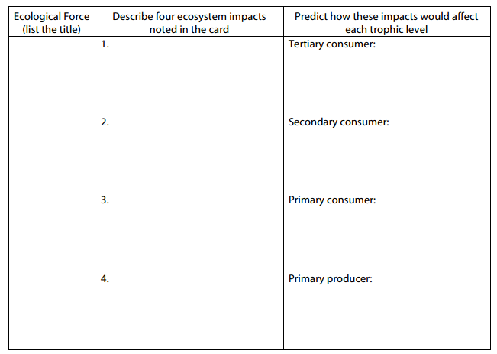

7. Not all disturbances have negative consequences for all trophic levels. In one or two sentences, describe a possible benefit that one trophic level in your food chain may gain from the disturbance you selected.

Part 2: Creating a food web
Food chains are simple models that show only a single set of energy-transfer relationships, but many organisms obtain energy from many different sources and in turn may provide energy to several different consumers. A food web illustrates all these interactions and is a more accurate model of how energy moves through an ecological community.

8. Starting with your original food chain, add another plant and four more animal cards to construct a food web that shows how energy flows from producers through primary consumers, secondary consumers, tertiary consumers, and possibly a quaternary consumer. When making your food web, you can have more than one arrow leading to and from each organism. Draw a version of your food web below

9. In one or two sentences, describe any patterns you notice in the relationships between trophic levels.

10. Now choose and read a different disturbance card and predict its impact on your food web. Complete the table below:
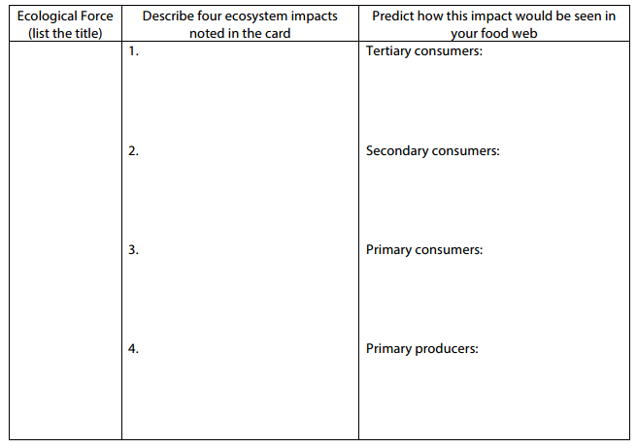
15. Describe whether some trophic levels benefit from the disturbance while others do not. If the disturbance was caused by humans, was it negative or positive for each trophic level in the food chain?

