AP Biology 12
The Chemistry of Life and The Cell "Building the Foundations"

Concept 1: Analyzing and the chemistry of life (Ch 2-5)
Chapter 2: The Chemical Context of Life (reading package)
Chapter 3: Water and Life

Why is Water So Special?

The Structure of Water

- Covalent bonds between the ________
- A polar molecule – charge ________________
- 2 water molecules will form a loose, weak bond known as a ____________________

There are 4 properties of water that contribute to Earth’s suitability for life.

1. _____________________________

- other charged particles can _______________in it. For example:

_________________substances are water-soluble
________________ substances are non-polar (oil) and do not dissolve in water.

2. ______________________________(water molecule joined to water molecule)

_____________________- water molecule attached to some other molecule
______________________movement up thin xylem tubes and evaporation through stomata
Water molecules __________ together due to the hydrogen bonding buy the flow __________.
Our blood is ______ water. Water helps our joints to move ________________.

Activity: How is the Surface Tension of Water Affected By Soap
3. _________________________________

High ____________________________
Hydrogen bonds absorb heat _______________ and then hold it for a___________ time
This is why there are ____________fluctuations in our body temperatures and in the _______
Also sweat uses body heat to evaporate it and this _____________ the body down

4. _________________________________

Water is ________________as a solid than a liquid, therefore, ice floats.
This keeps large bodies of water from freezing solid and therefore ______________________.

Reactions that Involve Biological Molecules & WATER
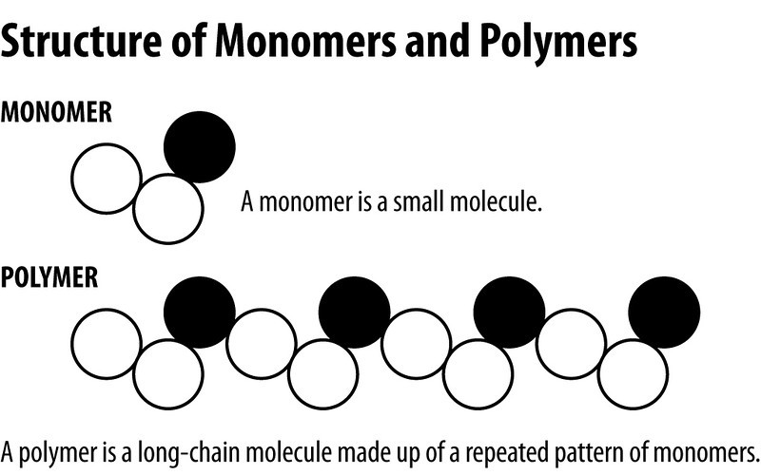

Monomers: small _______________that can be chemically bonded to form polymers e.g. glucose, fatty acids, nucleotides and amino acids
Polymers: large molecules made up of a linked series of repeated simple _____________e.g. polysaccharides such as glycogen, starch and cellulose and also DNA, proteins and fats.
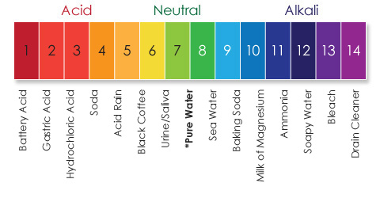

Interpreting the pH Scale

What is an acid?
What is a base?
What is a buffer?

An essential buffer in our bodies is ___________________. It moderate pH in blood…and in the ocean!

Chapter 4: Caron and the Molecular Diversity of Life

Carbon needs _______covalent bonds to ‘feel satisfied’. Instead of drawing the electrons all the time, we draw _______________to represent a ______________(covalent bond)

An isomer is:

Other important elements:

If arranged in single bonds, the carbon molecule can be _________________.
    - Ex:
If arranged in double bonds, the carbon molecule must be________________.
    - Ex:
Functional Groups allow for ________________________.
Examples:

Chapter 5: The Structure and Function of Macromolecules
To prepare:
- Read Holtzclaw p 38-42
- Campbell
  - Examine at figures from Chapter 5
  - Read “Exploring Protein Structure” Pg. 82-83
  - Read “Inquiry 5.25” p. 86

