Analyzing how plants detect and defend themselves against herbivores & environmental stresses (Ch 39)
You must know:
- The three steps to a signal transduction pathway
- The role of auxins in plants
- The survival benefits of phototropism and photoperiodism use changes in environment to modify plant growth and behaviour
- How plants respond to attacks by herbivores and pathogens
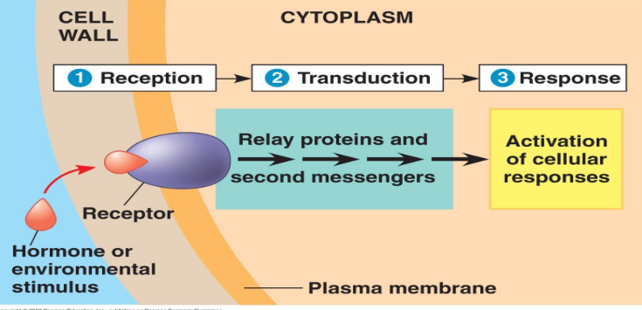
Signal transduction pathway
Reception: Receptors undergo changes in shape due to an environmental stimulus. Most are in the ___________________ some are in the cytoplasm.
Phytochrome- an example of a receptor in the cytoplasm. It’s a __________________protein. It is involved with a plants ability to grow in the dark, referred to as _____________________.
Transduction: Amplification of signal through a ___________________pathway. Allows small signal to produce large cellular response. Uses protein kinases (phosphorylation cascade) and second messengers (Ca2+ and cAMP)
Light causes phytochrome to change shape. One activated phytochrome molecule may trigger hundreds of molecules of a second messenger, each of which may lead to the activation of hundreds of enzymes.
Response: Two ways response is accomplished:
- Transcriptional Modification: __________________mRNA production (turning genes on/off)
- Post-Translational Modification: Activates existing enzyme molecules

Plant Hormones
Hormones: chemical messengers that coordinate the different parts of a multicellular organism
Tropism: Plant growth response toward or away from a stimulus
Phototropism
Gravitropism

Examples of hormones
Auxins – stimulate elongation of cells within young developing shoots
Cytokinins – stimulate cell division (roots)
Gibberellins – stimulate stem elongation, pollen, fruit, seed development
Abscisic acid – promotes stomatal closure during drought stress
Ethylene (gas!) – fruit ripening, leaf abscission

Phototropism - Mechanism
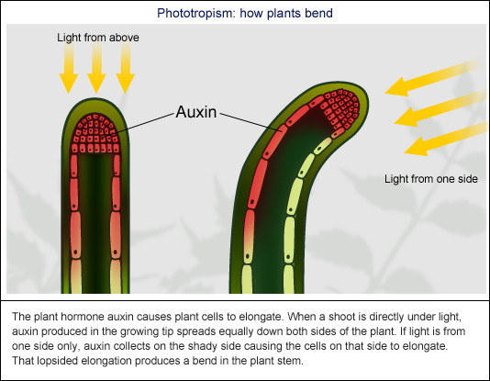
A plant’s response to light is critical for its success
2 classes of light receptors
Phytochromes & Blue-light photoreceptors
Plants can detect the presence of light as well as the direction, intensity and ____________________.

Biological clocks & circadian rhythms
Photoperiodism – physiological response to a photoperiod (relative lengths of day and night)
Example: Flowering
Circadian rhythms – physiological cycles that have a frequency of about 24 hours

Gravitropism, response to gravity, roots display positive gravitropism and shoots exhibit negative gravitropism.
Auxin plans a key role in this.

Responses to Mechanical Stimuli

Herbivore Defense

Environmental Stress

