Protein Synthesis- Act it out! Name: _________________ Date: ____________
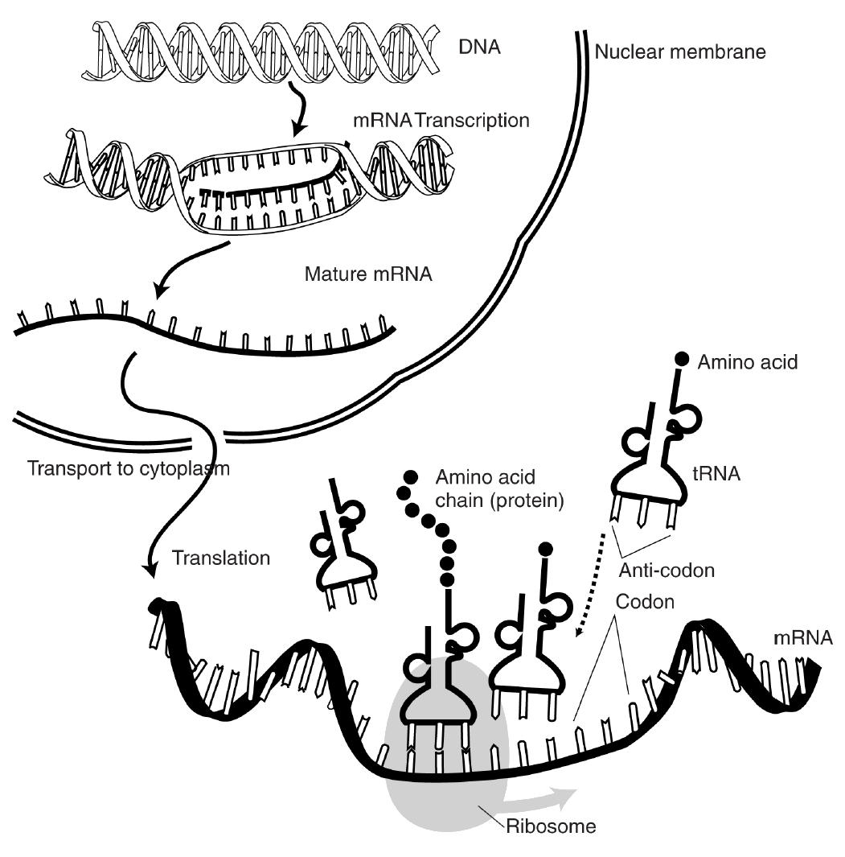
Today we will be acting out protein synthesis. In our classroom, the board is the nucleus and the floor is the cytoplasm. You and your partner will each have a specific job. One of you will be mRNA and one will be tRNA. Your desk will act as the ribosome (in the cytoplasm, of course!).

Pre-Lab Questions

- Describe the parts of the cell that are used in this activity. Which parts of our classroom represent the nucleus, cytoplasm, and ribosome? What do each of these do?

- What is the function of mRNA? In our play, what will mRNA be doing?

- What is the function of tRNA? In our play, what will tRNA be doing?

Procedure:
- Determine which person will be the mRNA and which will be the tRNA.
- Send the appropriate person to the nucleus to transcribe RNA from the DNA template strand provided. Use only one strand of DNA on the board. Record your mRNA sequence in the space provided.
- Next, your mRNA leaves the nucleus and travels to the ribosome (desk). At your desk, ‘read’ the mRNA strand and use the codon to determine the appropriate amino acid sequence. Write the amino acid sequence in the space provided on this sheet.
- Now, determine which person should leave the ribosome to go pick up the appropriate amino acid. Have that person go to the desk with amino acids and bring them back to the ribosome, one at a time.
- Attach your amino acids together in the correct order using peptide bonds (tape)
- Attach your completed amino acid on the back of this paper.

Which RNA strand goes to the nucleus to transcribe RNA from DNA?

At the Ribosome:

mRNA sequence:

mRNA codons:

tRNA anticodons:

Amino Acid Sequence:

Which RNA strand leaves the ribosome to pick up the amino acid?

Completed amino acid: (Label the bonds between amino acids)

What enzyme did we leave out of this story? What does it do?

How does the ribosome know it’s time to stop translation and disassociate?

How are the DNA, mRNA and tRNA that same? Different?

