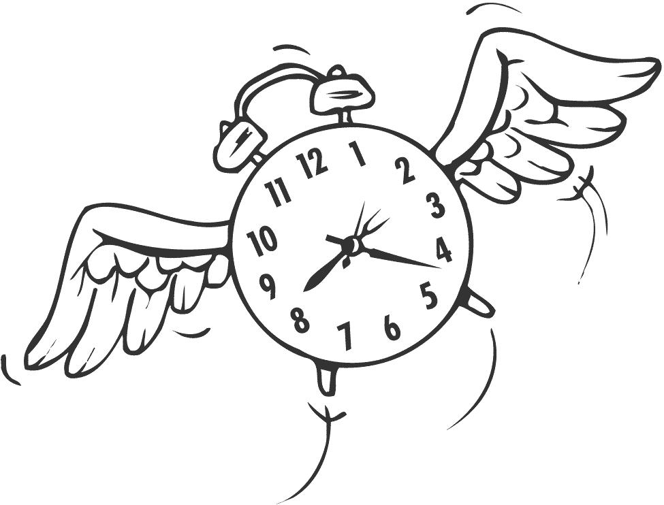
A Week in the Life of….

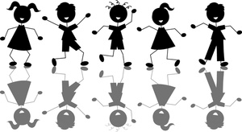
“There’s no secret to balance. You just have to feel the waves” – Frank Herbert

10 080 minutes. This week you are going to keep a log on how those minutes are spent. How long do you sleep? What about the time spent in the bathroom? How much of your day is in a classroom? You might be surprised.

You are going to create a report all about your week

Data Collection: You are going to diligently record how many minutes you spend doing various activities in your week. The more accurate data you collect, the more valuable your results will be. You can record your minutes on paper, in an excel sheet or on your phone (print it out) and attach it in the data section of your report. (See chart below)

Introduction

How are you going to collect the data?

_______________________________________________________________________________________

Why are you being asked to do this? What is the point of this activity?

_______________________________________________________________________________________

_______________________________________________________________________________________

What are you expecting to see after collecting your minutes?

______________________________________________________________________________________

_______________________________________________________________________________________

Data Analysis: Look at the minutes you spent over the week. Put your minutes into the following categories using an excel spreadsheet:

Categories | Total Minutes
Spirituality
Physical Activity
Sleep
Physical Appearance
Environmental Impact
Intellectuality
Employment
Socializing
Family
Recreational Technology
Defining the Categories

Spirituality - manage stress, reflect on values and beliefs, respect the beliefs and values of others
Examples: yoga, listening to music, church, gardening, volunteering, meditation, drawing, spending time in nature

Physical Activity –any bodily activity that enhances or maintains physics fitness and overall health
Examples: being active, sports, walking, dance

Sleep – a natural periodic state of rest for the mind and body

Physical Appearance – self-care practices
Examples: going to the doctor/dentist, personal hygiene, showering, make up, picking out clothes

Environmental Impact – creating a safe and sustainable community that recognizes the impact of personal and social environmental decisions
Examples: walking or taking the bus, reduce your waste, eat locally, re-use materials, toxic free personal care products

Intellectuality – expanding knowledge and seeking mental stimulation
Examples: in class learning, homework, studying, research, personal inquiry

Employment – condition of having paid work
Examples: part-time job, baby sitting, chores

Socializing – developing and maintaining healthy relationships with those around you
Examples: spending time with people, hanging out with friends, communicating and resolving conflicts

Family – a network of people you can rely on
Examples: parents, siblings, neighbours, grandparents, godparents, aunts and uncles

Recreational Technology – refreshing of one’s mind or body through different technologies
Examples: watching TV, texting, gaming, Facebook, talking on the phone, Twitter, YouTube

Representing Data: Create two visual representations of your time spent in the week.

Circle Graph

Use the totals for each category listed above to create a circle graph in Excel. Highlight the data, click on charts and choose the circle graph. Use the formatting palette to add a title and percentages. Copy and paste your circle graph into a word document and enlarge it to half a page. Print your circle graph. Use coloured pencils to identify the sectors with the legend. Attach your circle graph to the larger bar graph poster.
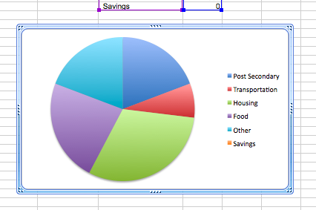

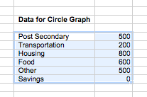
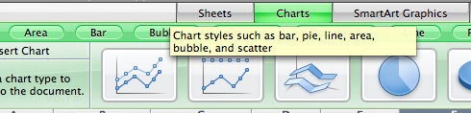

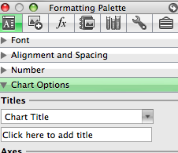
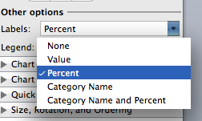
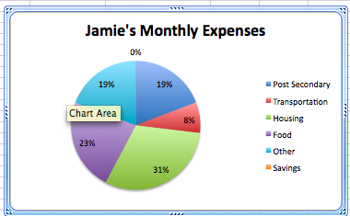

Bar Graph
Create by hand on paper no bigger than half the size of a poster board.

Steps:

- Decide on a title for your graph
- Draw the vertical and horizontal axes.
- Label the horizontal axes
- Write the names of the categories where the bars will be
- Label the vertical axes
- Decide on an appropriate scale.
- Draw a bar to show the total for each category
- Fill bars with pictures that relate to each category

Conclusion and Reflection

Summary of results and what they mean, compare the categories of time spent

Discuss interesting findings – what surprised you and why? Are you balanced?

List all sources of error or mistakes you may have made without realizing – be thorough. Do the graphs accurately represent that data? Why or why not?

Make a connection to the big picture (relevance) – why is it important?

Compare the bar graph and the circle graph – which one is the most effective to represent the data and why?

Ask new questions on this topic – that you could study in the future

Conclusion and Reflection (Criterion D: Reflection in mathematics)

Data Analysis

D1 critique ways in which data is presented
[C, R, T, V]
Achievement level | Level descriptor | What does this mean?
0 | The student does not reach a standard described by any of the descriptors below.
1-2 | The student attempts to explain whether his or her results make sense in the context of the problem.  The student attempts to describe the importance of his or her findings in connection to real life where appropriate. | Has some errors in understanding or is incomplete  ☐summary and comparison of results  ☐discussion of findings  ☐sources of error and misrepresenting data  ☐connection and relevance  ☐comparing graphs  ☐extension and further study
3-4 | The student correctly but briefly explains whether his or her results make sense in the context of the problem.  The student describes the importance of his or her findings in connection to real life where appropriate.  The student attempts to justify the degree of accuracy of his or her results where appropriate. | Completed but does not provide many details  ☐summary and comparison of results  ☐discussion of findings  ☐sources of error and misrepresenting data  ☐connection and relevance  ☐comparing graphs  ☐extension and further study
5-6 | The student critically explains whether his or her results make sense in the context of the problem.  The student provides a detailed explanation of the importance of his or her findings in connection to real life where appropriate.  The student justifies the degree of accuracy of his or her results where appropriate. The student suggests improvements to his or her method where appropriate. | Thorough and thoughtful  ☐summary and comparison of results  ☐discussion of findings  ☐sources of error and misrepresenting data  ☐connection and relevance  ☐comparing graphs  ☐extension and further study

“Life is like riding a bicycle. To keep your balance you must keep moving” - Einstein

