For each table of values, tell whether the relationship is linear. Explain how you know.

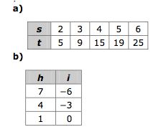

a) Graph the ordered pairs in the table of values.

b) What is the difference in value for consecutive *x*-values?

c) What is the difference in value for consecutive *y*-values?

d) What is an expression for *y* in terms of *x*?





**Math 8 - 9.2 Try This!**