**Genetics Problems: Pedigrees**

NOTE: Individuals whose phenotype or genotype cannot be determined are assumed to be homozygous normal, unless otherwise indicated.

**Multiple Choice Question 1**

Widow’s peak is an autosomal dominant condition. The pedigree given shows a family in which shaded individuals have the condition.

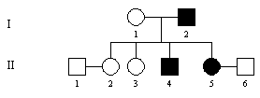

1. Individual I1 is heterozygous for the trait
2. Any child of II5 and II6 will show the trait
3. At least one parent of I2 has the trait
4. Any child of II1 and II2 has a one in two chance of having the trait

**Multiple Choice Question 2**

Consider the following pedigree.



The most likely mode of inheritance is:

1. Autosomal recessive
2. Autosomal dominant
3. X-linked recessive
4. X-linked dominant

**Short Answer Question 1\***

Phenylketonuria (PKU) is an autosomal recessive condition in humans and has the alleles for the normal enzyme phenylalanine hydroxylase (P) and lack of enzyme (p). The shaded person in the following pedigree has the disease.

1. Assign possible genotypes for each individual in the pedigree.



1. What is the chance that a child of III1 and III2 would have PKU?
2. What is the chance that their first child is a PKU son?
3. If III1 and III2 have four children, what is the chance that three have PKU and one is normal?

**Short Answer Question 2**

The trait shaded in the following pedigree is inherited as an autosomal recessive trait with the alleles K and k.



1. What is the chance that individual II-1 is heterozygous for the trait?
2. What is the chance that individual II-3 is homozygous at the gene locus concerned?
3. What is the chance that individual III-3 is genotype KK?
4. If individual III-1 marrries a male heterozygous for the trait, what is the chance that their first child will show the trait?

**Short Answer Question 3**

Examine the following pedigree. Individuals with the trait under investigation are shaded.



1. What is the mode of inheritance of the trait? Give reasons for your choice.
2. What is the chance that II-3 is heterozygous at the gene locus involved?
3. What is the chance that III-1 is heterozygous at the gene locus involved?
4. What is the chance that III-7 is heterozygous at the gene locus involved?

**Short Answer Question 4**

Study the pedigrees of family A and family B in the figure below.

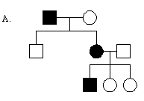 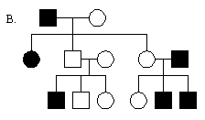

1. Which family pedigree shows an autosomal dominant mode of inheritance? Give reasons for your choice.
2. What type of inheritance is demonstrated by the other family? Why did you decide on that type of inheritance?

**Short Answer Question 5**

The following family shows an example of an X-linked dominant type of inheritance.

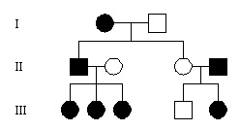

 

1. Assign allele symbols for the faulty enamel gene.
2. What is the genotype of a male with a faulty enamel trait?
3. What genotypes can females with the trait have? What genotype must normal females have?
4. What is the genotype of individual III-5?
5. Explain whether individual III-1 inherited the faulty enamel gene from her mother or her father.

**Short Answer Question 6**

Cystic fibrosis is inherited as an autosomal recessive trait, as shown in the pedigree below.

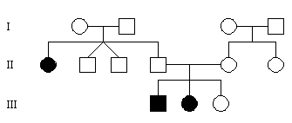

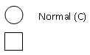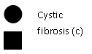

1. How many genotypes are possible for individual III-3? What are they?
2. Is individual II-4 homozygous or heterozygous for this trait? Explain.
3. Because individuals II-2 and II-3 are twins, would they have exactly the same genotype for cystic fibrosis? Explain.

**Short Answer Question 7**

A survey of male and female Biology students found that some individuals have one whorl of hair at the crown of the head whereas others have two whorls. This was investigated further in two families; Family A and Family B. Data collected from these families were recorded in two pedigrees shown below.

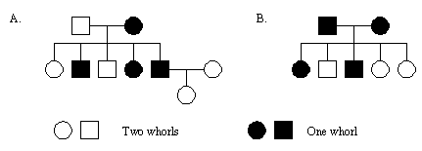

1. Which of the pedigrees, A or B, will fit more than one pattern of inheritance?
2. Consider the pedigree not chosen in part a. Explain what feature of this pedigree allows you to decide that the inheritance of a single whorl is dominant.
3. Describe one feature of the pedigree considered in part b which indicates that the inheritance of one whorl is autosomal dominant and not X-linked dominant.

**Short Answer Question 8**

Don and his maternal grandfather, Barry, both have haemophilia A. Don’s partner Diane is his maternal aunt’s daughter. Don and Diane have one son, Edward and two daughters, Elise and Emily, all of whom have haemophilia A. They also have an unaffected daughter, Enid.

1. Draw the pedigree
2. What is the most likely mode of inheritance of haemophilia A?
3. What evidence in this family’s pedigree supports your decision?
4. Why are Elise and Emily affected?
5. What is the probability that a son of Elise would be haemophiliac?
6. What is the probability that her daughter would be haemophiliac?
7. What is the probability that a son of Enid would be haemophiliac?
8. What is the probability that a daughter would be haemophiliac?

**Short Answer Question 9**

Study the pedigree below, which shows the inheritance of a disease in humans. The disease is caused by a single gene with dominant (T) and recessive (t) alleles.

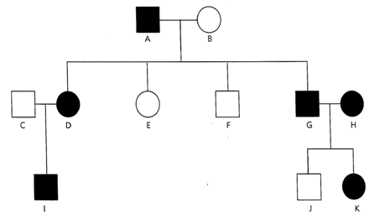

1. Identify the sex of the person labelled G
2. Identify the letter symbols of two males who have the disease

Answer the following questions to determine whether the disease is caused by the dominant or recessive allele.

Suppose the disease was caused by the recessive allele.

1. Identify the genotype of G and H
2. Identify the only possible genotype of their offspring
3. Could they produce a child (J) without the disease?

Suppose the disease was caused by the dominant allele.

1. Identify the possible genotypes of G and H
2. Identify the possible genotypes of their offspring
3. Could they produce a child (J) without the disease?
4. Assign genotypes to the following individuals: A, B, I, K.

**Short Answer Question 10**

Consider the following pedigree.



1. What is the most likely mode of inheritance for the trait?
2. What key feature(s) of the pedigree were important in determining the answer to part a?
3. Assign an appropriate allele pair for the gene responsible for the trait and assign possible genotypes to the individuals in the pedigree.
4. If individual III-6 marries a male lacking the trait, what is the chance that their first son will have the trait?
5. With regard to the trait in this pedigree, select the correct alternative.

i. All unaffected females would be homozygous recessive

ii. All affected females would be homozygous dominant

iii. All unaffected males would be hemizygous dominant

iv. All unaffected males would be hemizygous recessive

**Short Answer Question 11**

The trait shaded in the following pedigree is inherited as an autosomal recessive with the alleles K and k.



1. What is the chance that individual II-1 is heterozygous for the trait?
2. What is the chance that individual II-3 is homozygous at the gene locus concerned?
3. What is the chance that individual III-3 is genotype KK?
4. If individual III-1 marries a male heterozygous for the trait, what is the chance that their first child will show the trait?

**Short Answer Question 12**

The trait shown in the following pedigree is dominant.



1. Is the trait autosomal or X-linked?
2. Explain your answer to part a.
3. Which of the following females is heterozygous for the trait: II-1, II-8, III-1, III-3?
4. Which of the following males is heterozygous for the trait: II-2, II-6, III-2, III-5?
5. What is the chance that the next child of couple II-1 and II-2 will show the trait?
6. If III-1 married III-5, what would be the chance that their first child would be heterozygous for the trait?

**Answers**

**Multiple Choice Question 1**

C

a. No, must be homozygous recessive

b. Can show the trait, but can’t be sure

c. Yes, otherwise he couldn’t be affected

d. No, can’t have the trait at all

**Multiple Choice Question 2**

A

a. Yes – works out

b. Can’t be as two unaffected parents couldn’t have an affected child

c. Can’t as parents would be XRXr and XRY and therefore couldn’t have an affected daughter who must be XrXr.

d. Can’t be as two unaffected parents couldn’t have an affected child

**Short Answer Question 1**

a. I1 = Pp, I2 = Pp, II1 = P_, II2 = P _, II3 = pp, II4 = P_, II5 = P_, III1 = P_, III2 = P_

b. III1 = P_ and III2 = P_

Both must be heterozygous to have a child with the disease.

Chance of III1 being heterozygous = 2/3 x 1/2 = 1/3

Chance of III2 being heterozygous = 2/3 x 1/2 = 1/3

If they’re both heterozygous, chance of having a PKU child is 1/4

Total probability = 1/3 x 1/3 x 1/4 = 1/36

c. 1/36 is the chance that any child of theirs is PKU. Only 50% chance of being a son. Therefore 1/36 x ½ = 1/72.

d.





**Short Answer Question 2**

a. Parents: K_ and K_

However, they have produced a child with the trait, so must be Kk and Kk.

|  |  |  |
| --- | --- | --- |
|  | K | k |
| K | KK | Kk |
| k | Kk | kk |

We already know II-1 does not have the trait, so can disregard kk. Chance of them being heterozygous = 2/3.

b. Parents are Kk and Kk.

Already know they don’t have the trait, so disregard possibility of kk.

Chance of being homozygous (using Punnett square above) = 1/3.

c. II-4 must be kk, and II-5 must be Kk, given that they produce a child with the trait.

|  |  |  |
| --- | --- | --- |
|  | K | k |
| k | Kk | kk |
| k | Kk | kk |

Not possible, as the father is affected and therefore can’t pass on the allele for the dominant trait.

d. kk x Kk

|  |  |  |
| --- | --- | --- |
|  | K | k |
| k | Kk | kk |
| k | Kk | kk |

Chance of first child showing the trait = 50%

**Short Answer Question 3**

a. Can’t be autosomal dominant, as II-5 and II-6 (both rr) would not be able to have an affected child (III-6) who would need an R allele.

Can’t be X-linked dominant, as II-5 (XrXr) and II-6 (XrY) couldn’t have an affected child (III-6) who would need to be XRY.

Can’t be X-linked recessive, as II-1 (XRY) and II-2 (XrXr) as all their male children must then be affected, obtaining Y from their father and Xr from their mother. However, they have an unaffected son.

Therefore, must be autosomal recessive.

b. Parents: Rr x rr (both must have r as they produce an affected child)

|  |  |  |
| --- | --- | --- |
|  | r | r |
| R | Rr | Rr |
| r | rr | rr |

Therefore, 50% chance.

c. Must inherit an R from dad, and must inherit an r from mum, therefore 100% chance.

d. Parents must both be Rr as they don’t have the trait but produce an affected child.

|  |  |  |
| --- | --- | --- |
|  | R | r |
| R | RR | Rr |
| r | Rr | rr |

50% chance

**Short Answer Question 4**

a. Pedigree A. Can’t be pedigree A as individuals II-2 and II-3 (both dd) couldn’t have an affected child (III-1) as they would have to inherit a D allele.

b. Can’t be autosomal dominant or X-linked dominant as two unaffected parents (II-2 and II-3) couldn’t have an affected child (III-1).

Could be autosomal recessive, but more likely to be X-linked recessive as there are many more males than female affected.

**Short Answer Question 5**

a. XR = faulty enamel and Xr = normal enamel.

b. XRY

c. With trait – XRXr or XRXR

Normal - XrXr

d. XRXr

e. Her father, as mother must have two normal alleles in order to not show the trait, and therefore could not pass on the faulty enamel allele.

**Short Answer Question 6**

a. Two – Rr or RR

b. Heterozygous. Must have an allele for the dominant trait in order to not have the disease. Must have an allele for the recessive trait in order to produce an affected child.

c. Yes – the pedigree shows that they are identical twins, meaning they must have exactly the same genotypes.

**Short Answer Question 7**

a. Pedigree A

b. It can’t be recessive as two affected parents (II-1 and II-2, who would be rr) couldn’t have affected children (II-2, II-4 and II-5) who would have to inherit an R.

c. If it was X-linked dominant, individuals II-4 and II-5 would have to inherit an XR allele from their father, giving them the trait.

**Short Answer Question 8**

a.

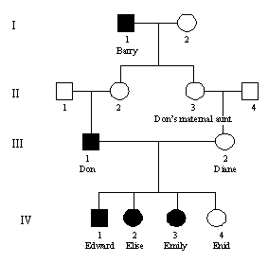

b. X-linked recessive

c. Must be recessive as two unaffected parents (II1 and II2) produce an affected child (III1)

Could be autosomal recessive, but more likely to be X-linked recessive

d. Must inherit X r (affected allele) from the father and also inherited X r from their mother.

e. 100% - must pass X r onto her son

f. Assuming mating with homozygous normal, 0%, as daughter will inherit normal allele from father, overriding affected allele. Daughter will only be a carrier.

g. 50% - will either inherit XR or Xr from Enid and Y from father.

h. 0%, assuming mating with a homozygous normal. But daughter may be a carrier.

**Short Answer Question 9**

a. Male

b. Any two of A, G and I

c. Both tt

d. tt

e. No

f. Tt or TT

g. TT, Tt, tt

h. Yes

i. A = Tt B = tt I = Tt K = TT or Tt

**Short Answer Question 10**

a. X-linked dominant

b. All daughters of an affected male are affected, therefore it is likely to be X-linked.

Can’t be X-linked recessive as individuals I-1 (XrXr) and I-2 (XRY) couldn’t produce an affected daughter (II-1) who would have to have the genotype XrXr.

c. XT = affected allele and Xt = normal allele.

I-1 = XTXt I-2 = XtY

II-1 = XTXt II-2 = XtXt II-3 = XtY II-4 = XTY

III-1 = XTXt III-2 = XtY III-3 = XtY III-4 = XTXt III-5 = XTXt III-6 = XTXt

d. XTXt x XtY

|  |  |  |
| --- | --- | --- |
|  | Xt | Y |
| XT | XT Xt | XT Y |
| Xt | Xt Xt | Xt Y |

50% chance

e. Statement i

**Short Answer Question 11**

a. Parents are Rr x Rr

|  |  |  |
| --- | --- | --- |
|  | R | r |
| R | RR | Rr |
| r | Rr | rr |

However, already know she is not affected, so disregard rr.

Probability = 2/3

b. Parents are Rr x Rr

Already know he is not affected, so disregard rr.

Probability = 1/3

c. 0 – must inherit a k from her father, who is kk.

d. Rr x rr

|  |  |  |
| --- | --- | --- |
|  | R | r |
| r | Rr | rr |
| r | Rr | rr |

Probability = 50%

**Short Answer Question 12**

a. Autosomal

b. Can’t be X-linked as individual II-7 would be XRY and would have to pass on the affected allele to his daughter (III-3), meaning she would have to have the trait.

c. II-1

d. III-5

e. Rr x rr

|  |  |  |
| --- | --- | --- |
|  | R | r |
| r | Rr | rr |
| r | Rr | rr |

Probability = 50%

f. rr x Rr

|  |  |  |
| --- | --- | --- |
|  | R | r |
| r | Rr | rr |
| r | Rr | rr |

Probability = 50%