A store advertises 40% off all merchandise. You purchase sneakers regularly priced at $120. There is 12% tax. 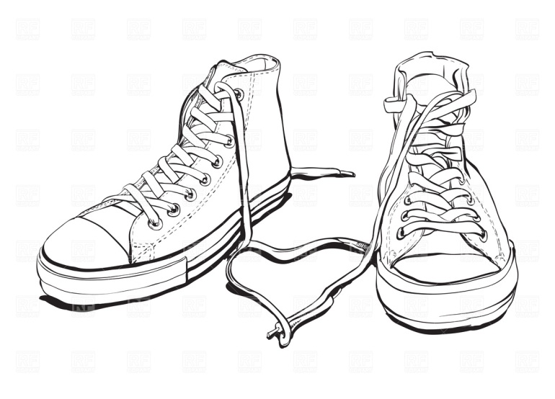 | You buy a TV that is regularly priced at $699. It was 20% off the first day and then an additional 15% off the second day. There is 12% tax.
At your favorite clothing store…the sign says 35% off the lowest ticketed price! You purchase a sweater regularly $89.00 but has a sticker on it that says 20% off. There is 12% tax.  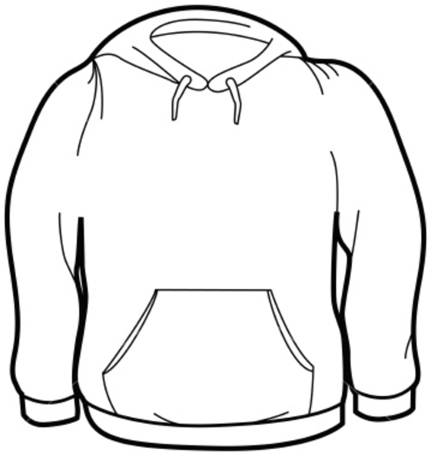 | You are getting some new gear for the ski season. You buy a helmet that has a sale price of $97.50. It was discounted by 30%. What was the original price? (no tax!)

