**Unit 3 – Pythagorean Relationships**

Video: <http://www.youtube.com/watch?v=NyLvCHwLzVE>

**3.5 Applications**

The Pythagorean theorem can be used to determine is the triangle is a __________ triangle. 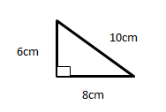

The Pythagorean relationship can be used to determine distances that might be ­­­­­­­____________or________________ to measure.

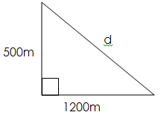

Brad places a 10m ladder up against a building so that it reaches the second floor window. The base of the ladder is 2m from the base of the house. How high is the second floor window?

A cruise ship travels from Port Stanley north at a speed of 32km/h for 3 hours. Then it turns 900 and travels west at 29km/h for 6.8 hours. When it reaches its final destination at that time, how far is the ship from where it started at Port Stanley?

Using the picture below, determine the height of the lamp pole.

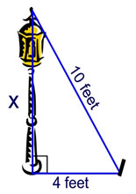

Brooke wants to swim across a river that is 100m wide. As she begins to swim the current carries her 70m downstream. How far did she actually swim?

Frances wants to put a fence around her vegetable garden to keep out the rabbits. Her garden is in the shape of a right triangle.

a) If the hypotenuse is 4m and one side is 3m, what it the total length of fence she’ll need?

b) If fencing costs $3/m, how much will it cost in total?