

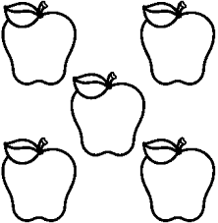

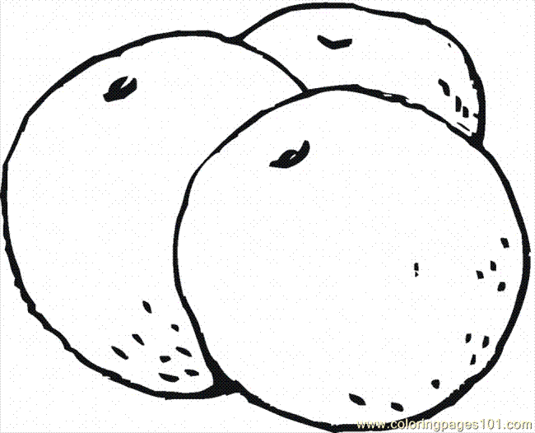

1. Owen wants to write the ratio of oranges to apples.

How does he know whether to write 3:5 or 5:3?

1. Your friend missed the class when ratios were introduced. Use an example and draw a diagram to explain the difference between a part-to-part ratio and a part-to-whole ratio.
2. Give two examples of how ratios are used in daily life. Share your ideas with a classmate
3. The fraction 2/5 can be interpreted as two parts out of a total of five parts. Use a diagram to show an example of this part-to-whole ratio.

Ashley has a recipe for fruit punch that calls for three cans of frozen orange juice concentrate, two cans of raspberry juice concentrate, and one can of lime juice concentrate. For each can of juice concentrate, the directions say to add three cans of water. All the cans are the same size. Ashley makes one recipe of fruit punch.

|  |  |  |  |  |
| --- | --- | --- | --- | --- |
|  | **Orange** | **Raspberry** | **Lime** | **Total** |
| Juice Concentrate (cans) |  |  |  |  |
| Water (cans) |  |  |  |  |
| Total Punch (cans) | | | |  |

1. What is the ratio of orange juice to lime juice concentrate? Express the ratio two different ways.
2. What is the ratio of lime to orange to raspberry juice concentrate?
3. What is the ratio of water to juice concentrate?
4. How many cans of punch does the recipe make?
5. What is the ratio of orange, raspberry, and lime juice concentrate to total punch? Express the ratio as a fraction, a decimal and a percent.