**11.1 Determining Probabilities Using Tree Diagrams and Tables**

*What is Probability anyways?*

Probability = the number of favourable outcomes

Total number of possible outcomes

Example 1: Determining Probabilities From a Tree Diagram

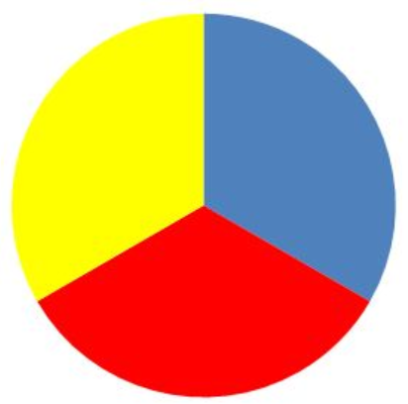

A spinner is divided into three equal regions as show below. The spinner is spun twice. For each probability you determine, express the answer as a fraction, a decimal and a percent.

B

B

A

|  |  |  |
| --- | --- | --- |
| 1. What is the probability of spinning A on the first spin? (Theoretical Probability) | | |
| Fraction | Decimal | Percent |
|  |  |  |

Here’s how to show it with the formula:

1. Now actually do it. Try ten times. Record your results below. Did you get A? (Experimental Probability)
2. Draw a tree to show the possibilities of spinning twice

|  |  |  |
| --- | --- | --- |
| Spin 1 | Spin 2 | Outcome |
|  |  |  |



B

A

B

1. What is the probability of spinning A followed by B: *P*(A and B)? (use the tree to help you). Represent your answer in a decimal, fraction and percent.
2. Now actually do it. Try ten times. Record your results below. Did you Theoretical probability match your experimental probability?
3. What is the probability of getting the same letter on both spins: *P*(A, A) or *P* (B, B) (Use the tree for help)
4. Now actually do it. Try ten times. Record your results below. Did you Theoretical probability match your experimental probability?

Example 2: Determine Probabilities from a Table

Two standard six side dice are rolled. One die is white and the other die is red. For each probability you determine, express the answer as a fraction, a decimal and a percent.

1. Create a table to represent the sample space:

|  |  |  |  |  |  |  |  |
| --- | --- | --- | --- | --- | --- | --- | --- |
|  | | Blue Die | | | | | |
| 1 | 2 | 3 | 4 | 5 | 6 |
| Red Die | 1 |  |  |  |  |  |  |
| 2 |  |  |  |  |  |  |
| 3 |  |  |  |  |  |  |
| 4 |  |  |  |  |  |  |
| 5 |  |  |  |  |  |  |
| 6 |  |  |  |  |  |  |

1. What is the probability of rolling a sum greater than ten? (use the table, express you answer 3 ways)

Roll the dice 10 times and see if your theoretical matches your experimental. Record your experimental data below:

1. What is the probability that the number on the red die is one larger than the number on the white die? (use the table, express you answer 3 ways)

Roll the dice 10 times and see if your theoretical matches your experimental. Record your experimental data below:

1. What is the probability that the sum of the two numbers is less than 11?

Roll the dice 10 times and see if your theoretical matches your experimental. Record your experimental data below:

|  |
| --- |
| **HOMEWORK: Workbook page 126-127 #6-10** |