Stewart recorded the following data about how he spends his day:

a) How would you make a bar graph to help argue that Stewart spends most of his time sleeping or going tot school?

b) How would you make a bar graph that Stewart could use to argue that he spends almost as much time on homework as he does at school?





|  |  |
| --- | --- |
| **Activity** | **Time (h)** |
| Chores | 1 |
| Eating | 2.5 |
| Homework | 2.5 |
| School | 6.5 |
| Sleep | 7 |
| Sports | 2.5 |
| TV | 2 |
| Total | 24 |

Misleading features include:

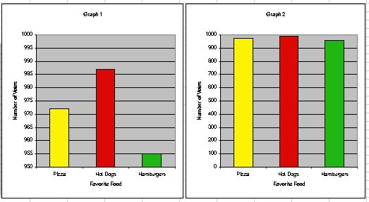 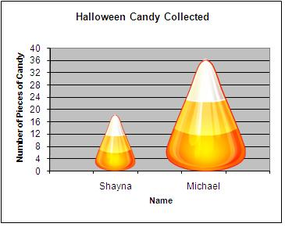

Misleading graphs can cause people to _________________________the data and draw __________________conclusions.